International
J/24
Class Rules

ISAF Submission Version

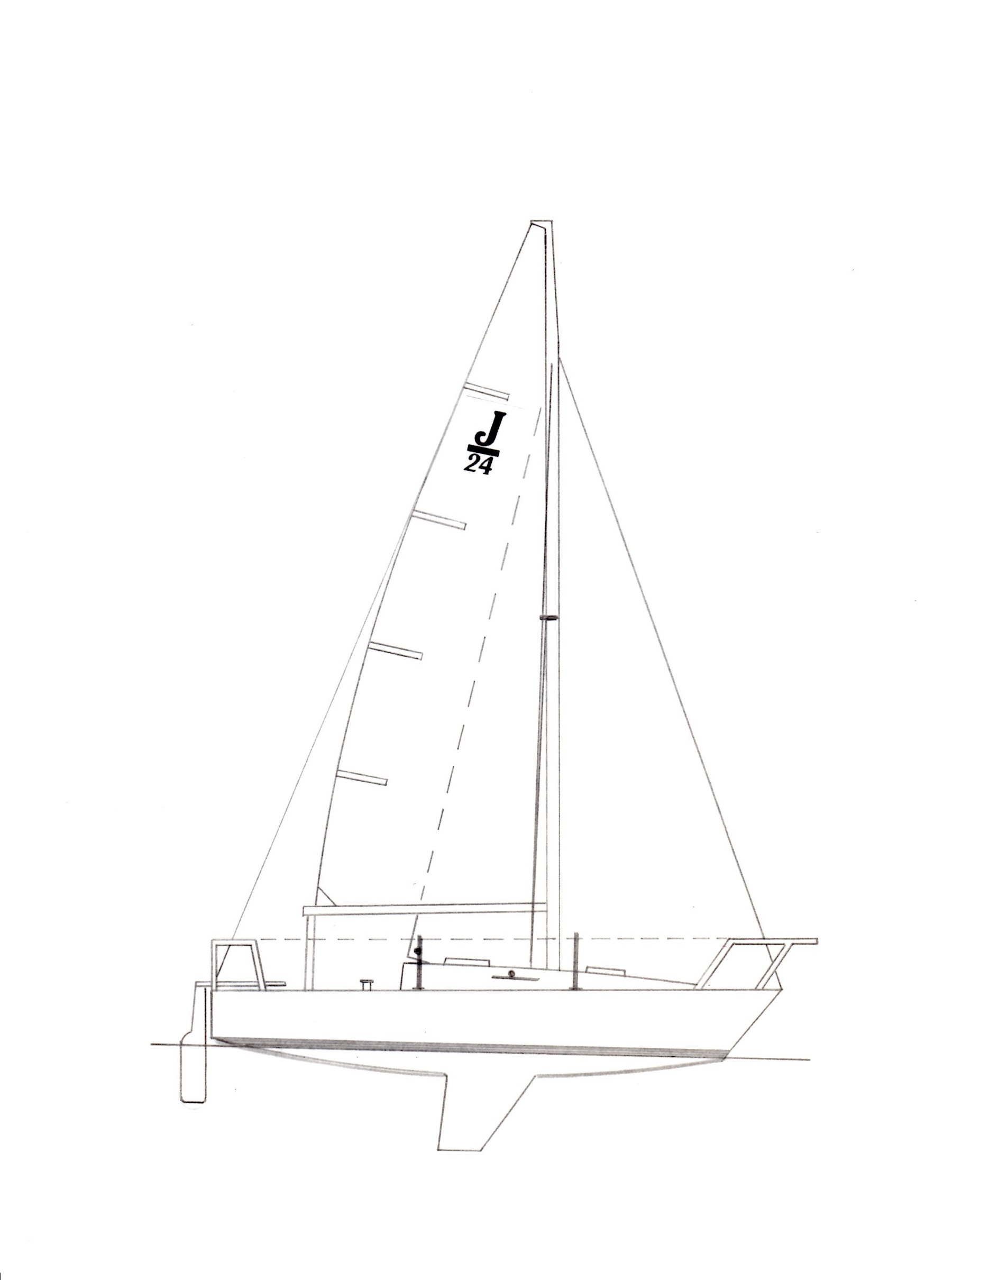

The J/24 was designed in 1976 by Rodney Johnstone and was adopted as an
international/recognised class in 1981.
Index

Part I – Administration
Section A – General
A.1 Language 4
A.2 Abbreviations 4
A.3 Authorities 4
A.4 Administration of the Class 4
A.5 Class Rules Changes at Events 4
A.6 Class Rules Amendments 4
A.7 Class Rules Interpretation 4
A.8 International Class Fee and
Licensed Manufacturers 5
A.9 Sail Numbers 5
A.10 Measurement Certificate 5
A.11 Initial Hull Certification 5
A.12 Validity of Certificate 5
A.13 Hull Re-Certification 6
A.14 Retention of Certification
Documentation 6
Section B – Boat Eligibility
B.1 Class Rules and Certification 7
B.2 Class Membership Requirements 7
B.3 Class Association Markings 7
B.4 Documentation to be Carried Aboard While Racing …………. 7
Part II – Requirements and Limitations
Section C – Conditions for Racing
C.1 General 8
C.2 Crew 8
C.3 Personal Equipment 9
C.4 Advertising 9
C.5 Portable Equipment 9
C.6 Boat 10
C.7 Hull 11
C.8 Hull Appendages 13
C.9 Rig 14
C.10 Sails 17
Section D– Hull
D.1 Parts 18
D.2 General 18
D.3 Hull Shell 19
D.4 Deck 19
D.5 Buoyancy Compartments 19
D.6 Bulkheads 19
D.7 Interior Liner 19
D.8 Assembled Hull 20
D.9 Weights……………………….. 20
D.10 Keel Stub …………………….. 20
Section E – Hull Appendages
E.1 Parts 21
E.2 General 21
E.3 Keel 21
E.4 Rudder Blade and Tiller 22
Section F – Rig
F.1 Parts 22
F.2 General 22
F.3 Mast 23
F.4 Boom 24
F.5 Spinnaker Pole 25
F.6 Standing Rigging …………….. 25
F.7 Running Rigging 25
Section G – Sails
G.1 Parts 26
G.2 General 26
G.3 Mainsail 27
G.4 Headsail - Genoa 29
G.5 Headsail - Jib 29
G.6 Spinnaker 30
Part III – APPENDICES
Section H - Plans 32
Section J - Event Rule Change
Options ……………………... 43

INTRODUCTION

This introduction only provides an informal background and the International J/24 Class Rules proper begin on the next page.
The J/24 was designed and built by Rodney Johnstone in 1976. The objective was to create a popular design that could be raced and cruised economically by a broad range of crews. The fact that many of the early boats are still racing at the top levels in the class along with the popularity of the J/24 would indicate that this objective has been successfully met. It is the intention of the International J/24 Class to continue that tradition with this conversion of our rules to the ISAF format.
J/24 hulls, hull appendages and rigs shall only be manufactured by builders licensed to do so under the copyright of J Boats, Inc. (557 Thames Street, P.O. Box 90, Newport, RI 02840, USA) – in the class rules referred to as licensed builders. Equipment is required to comply with the International J/24 Building Specification.
J/24 sails are measurement controlled to the designated dimensions and may be made by any manufacturer.
J/24 hulls, hull appendages, rigs and sails may, after having left the builder, only be altered to the extent permitted in Section C of the class rules.
Rules regulating the use of equipment during a race are contained in Section C of these class rules, in ERS Part I and in the Racing Rules of Sailing.

PLEASE REMEMBER:
THESE RULES ARE CLOSED CLASS RULES WHERE IF IT DOES NOT SPECIFICALLY SAY THAT YOU MAY – THEN YOU SHALL NOT.

COMPONENTS, AND THEIR USE, ARE DEFINED BY THEIR DESCRIPTION.

Part I – Administration
Section A – General
A.1 Language
A.1.1 The official language of the class is English and in case of dispute over translation the English text shall prevail.
A.1.2 The word “shall” is mandatory and the word “may” is permissive.
A.1.3 Except where used in headings, when a term is printed in “bold” the definition in the ERS applies and when a term is printed in “italics” the definition in the RRS applies.
A.2 Abbreviations
A.2.1 ISAF International Sailing Federation
MNA ISAF Member National Authority
ICA International J/24 Class Association
NCA J/24 National Class Association
ERS Equipment Rules of Sailing
RRS Racing Rules of Sailing
OSR Offshore Special Regulations
A.3 Authorities
A.3.1 The international authority of the class is the ISAF which shall co-operate with the ICA in all matters concerning these class rules.
A.3.2 Notwithstanding anything contained herein, the ICA has the authority to withdraw a measurement certificate and shall do so on the request of the ISAF.
A3.3 Neither the ISAF, the MNA, the ICA, the NCA nor an official measurer, an international measurer or an equipment inspector is under any legal responsibility in respect of these class rules for the accuracy of measurement. No claim arising against any of them shall be entertained.
A3.4 The Certification Authority is the ICA.
A.4 Administration of the Class
A.4.1 ISAF has delegated its administrative functions of the class to the ICA. The ICA may delegate part or all of its functions, as stated in these class rules, to an NCA.
A.4.2 In countries where there is no NCA, or the NCA does not wish to administrate the class, its administrative functions as stated in these class rules shall be carried out by the ICA which may delegate part or all of the administration functions to the appropriate MNA, if they are willing.
A.5 Class Rules CHANGES AT Events
A.5.1 RRS 87 applies.
A.6 Class Rules Amendments
A.6.1 Amendments to these class rules must follow procedures defined in the International J/24 Class Constitution and are subject to the approval of the ISAF in accordance with the ISAF Regulations.
A.7 Class Rules Interpretation
A.7.1 Interpretation of class rules shall be made by the ISAF, which shall consult with the ICA and J Boats, Inc. The ICA, an MNA or a licensed builder shall make a request for an interpretation.
A.7.2 In the event of discrepancy between any rules, drawings, specifications or measurement forms, the matter shall be referred to the ISAF.
A.7.3 Any interpretation of class rules at an event may be made by the ICA Technical Committee representative at the event or by an international jury constituted in accordance with the RRS, Appendix N. Such interpretation shall only be valid during the event and shall, as soon as practical after the event, be referred to the ISAF and the ICA to consider any adjustments that may be necessary going forward.
A.8 International Class Fee AND Licensed ManufacTUrers
A.8.1 Hulls, hull appendages and rigs may only be manufactured by licensed builders which are licensed by J Boats, Inc. Manufacturing must be in conformance with the building specifications from J Boats, Inc. and the class rules, including all plans.
A.8.2 There is an International Class Fee payable to the ISAF for each new boat built. This fee is controlled by an agreement between J Boats, Inc., the licensed builders and ISAF.
A.8.3 The licensed hull builder shall complete parts B & C of the class measurement form, which shall include both keel weight before assembly and “Builder’s Weight”, and supply that form to the ICA, J Boats, Inc. and the new owner.
A.9 Sail Numbers
A.9.1 Sail numbers shall correspond to the designated portion of the hull identification number moulded into the transom of each boat, unless otherwise prescribed by the owner’s national authority. When a boat is chartered or loaned, the boat’s sail number may be that of the member who chartered or borrowed the boat.
A.10 Measurement CertificatE
A.10.1 A Measurement Certificate shall record the following information:
(a) Class
(b) Certification authority - ICA
(c) Hull identification Number and related sail number
(d) Owner and owner’s contact information and signature
(e) Builder’s contact information and details in parts B & C
(f) Date of issue of certificate
(g) A list of items that have been checked and passed for certification
(h) The name(s) of measurer(s) involved in the certification process
(g) The Inventory of Required and Optional Equipment that is carried on the boat to identify the items included to reach all up weight, C.6.1.
A.10.2 It is the responsibility of an owner to ensure that the boat complies at all times
with the current class rules.
A.11 Initial Hull CERTIFICATion
A.11.1 For a measurement certificate to be issued to a hull not previously certified:
(a) Certification measurement shall be carried out by a class measurer (recognized by the ICA) who shall complete the appropriate documentation.
(b) The documentation and certification fee, if required, shall be sent to the certification authority (ICA).
(c) Upon receipt of a satisfactorily completed documentation and certification fee, if required, the certification authority may issue a certificate.
A.12 Validity of Certificate
A.12.1 A hull certificate becomes invalid upon:
(a) the change to any items recorded on the hull certificate as required under A.10.1 except the Inventory of Required and Optional Equipment (A.10.1(g)).
(b) the date of expiry,
(c) change of ownership,
(d) withdrawal by the certification authority,
(e) modifications, fairing or repairs beyond the depth of the gelcoat,
(f) the issue of a new certificate,
A.13 Hull RE-CERTIFICATION
A.13.1 The certification authority may issue a certificate to a previously certified hull:
(a) when it is invalidated under A.12.1(a), (b), (c) or (e), after receipt of a new measurement form (A.11.1(a)), and certification fee if required.
(b) when it is invalidated under A.12.1 (d), at its discretion.
A.14 Retention of certification documentation
A.14.1 The certification authority shall:
(a) retain the original documentation (measurement form) upon which the current certificate is based.
Section B – Boat Eligibility
For a boat to be eligible for racing, it shall comply with the rules in this section.
B.1 Class Rules and Certification
B.1.1 The boat shall:
(a) be in compliance with the class rules.
(b) have a valid measurement certificate.
B.2 Class Membership Requirements
B.2.1 The boat’s owner(s) shall be members of their country’s NCA or the ICA.
B.2.2 The boat’s skipper shall be a member of his/her country’s NCA or the ICA.
B.2.3 The boat’s driver shall be a member of his/her country’s NCA or the ICA.
B.3 Class Association markings
B.3.1 There shall be a current J/24 Class membership sticker on the outer face of the transom near the upper starboard corner.
B.3.2 Sails shall carry a Class Association Royalty label sewn onto the starboard side of the sail near its tack or near a spinnaker clew. Royalty labels shall not be transferred from one sail to another.
B.4 DOCUMENTATION TO BE CARRIED ABOARD WHILE RACING
B.4.1 The boat’s current Measurement Certificate.
B.4.2 A current Inventory of Required and Optional Equipment shall be carried at all times while racing. The Inventory of Required and Optional Equipment must match the actual equipment that is being carried at the time. For some regattas, this may include the royalty tag numbers for sails and the certification numbers of certified equipment on board. Special forms will be provided for those regattas requiring extra information on this form. The Inventory of Required and Optional Equipment will include the weight of all items included to make up the difference between the basic boat weight and the all up weight (C.6.1) as well as the weight of any corrector weights required. It is the boat owner’s responsibility to maintain this form, which is available from the class.
Part II – Requirements and Limitations
The crew and the boat shall comply with the rules in Part II when racing. In case of conflict Section C shall prevail.
The rules in Part II are closed class rules. Certification control and equipment inspection shall be carried out in accordance with the ERS except where varied in this Part.
Section C – Conditions for Racing
C.1 General
C.1.1 Rules
(a) RRS 41 is modified as follows: From the time a boat leaves her mooring for the first race of each day until she returns to her mooring and while not racing, she shall not receive outside help except as permitted by rule 41(a) through (d) from any outside source except other competitors and official boats under the direction of the organizing authority/race committee. If Race Signal “AP over H” is displayed by the RC, these additions to RRS 41 are suspended, until a boat leaves her mooring again to proceed to the racing area. While racing, rule 41 applies without modification. This also changes the preamble to Part IV of the RRS.
(b) RRS 42.3(b) is modified by adding “A boat’s crew may not hang on the mast or shrouds to promote roll tacking or gybing.”
(c) RRS 42.3(c) is modified to allow all parts of the mainsheet to be pulled simultaneously when this rule applies.
(d) RRS 44.3(a) is modified so that the yellow flag (code flag “I” is acceptable) used by a boat taking a scoring penalty shall have a hoist of not less than 150mm and a fly of not less than 200mm. The yellow flag shall be displayed from the backstay, above the deck.
(e) RRS 61.1(a) is modified so that the red flag displayed by a protesting boat shall have a hoist of not less than 150mm and a fly of not less than 200mm. The red flag shall be displayed from the backstay, above the deck.
(f) The ERS Part I – Use of Equipment shall apply.
C.2 Crew
C.2.1 Limitations – The crew shall consist of not less than three persons whose combined weight (in swim wear) shall not exceed 400kg. Any further limitations or adjustments to crew number, weight or substitution may be specified in event Sailing Instructions per RRS 87. See Section J.3 Crew Limitations for examples.
C.2.2 Crew Positioning
(a) Crew shall not stand and lean out over the lifelines, pulpit or pushpit to
promote roll tacking, roll gybing or to increase hiking leverage.
(b) While seated on the deck, crew shall have the base of their spine on the deck and inboard of the
Lifelines and the sheer plan at all times.

C.2.3 LIMITATIONS ON THE DRIVER
(a) Limitations on entries to championship events are described in the International J/24 Class
Regatta Regulations.
(b) The owner and driver may be the same or separate members of the crew, but must be the same
nationality.
(c) In events where qualification is required for participation, the driver must qualify for the event
per the International J/24 Class Regatta Regulations.
(d) The boat shall sail under the nationality (or nationality of permanent residency) of the owner (or
charterer).
C.3 Personal Equipment
C.3.1 Mandatory
(a) The boat shall be equipped with a personal floatation device for each crew member to the minimum standards of the country in which the boat is sailing.
C.4 Advertising
C.4.1 Limitations
Advertising shall only be displayed in accordance the ISAF Advertising Code. (See ISAF Regulation 20)
C.4.2 Boats may be required to display advertising supplied by the Organizing Authority of a regatta in which they are participating. Such advertising shall be located as directed and shall remain affixed for the duration of the regatta, unless otherwise specified.
C.5 Portable Equipment
C.5.1 MANDATORY (must be functional for its intended use)
(a) FOR USE WHILE RACING
(1) A minimum of one bucket of at least 9 liters capacity with a lanyard of at least one meter in length.
(2) One anchor with or without chain of not less than 6kg nor more than 9kg in weight and with not less than 40m of line of not less than 8mm in diameter. The anchor shall be secured against movement in the event of capsize.
(3) A minimum of one fire extinguisher: type and capacity to comply with local regulations.
(4) A minimum of one throwable lifesaving device with attached drogue (sea anchor) on deck and ready for use.
(5) Equipment capable of cutting the standing rigging.
(6) One marine first aid kit.
(7) A minimum of one water resistant flashlight.
(b) NOT FOR USE WHILE RACING
(1) One outboard engine of at least 12 kg. weight. The engine shall be stowed under a quarter berth or aft of the sill of the companionway. Both the engine its fuel shall be secured against movement in the event of capsize.
C.5.2 OPTIONAL (must be functional for its intended use)
(a) FOR USE WHILE RACING
(1) Electronic or mechanical timing devices
(2) Such extra lines and rigging as might be useful to repair minor damages or equipment failures on the water.
(3) Tape or other materials to make temporary repairs to the hull.
(4) One spare, measured rudder, tiller, tiller extension, any of which may be substituted on the water without permission of a jury or RC. See also C.8.2.
(5) One spare, measured spinnaker pole which may be substituted on the water without permission of a jury or RC.
(6) Foam and/or plastic cushions may be fitted to the lifelines.
(7) Up to four berth cushions, not exceeding a total of 21kg.
(8) A companionway step box or ice box located but not attached between the bunks on the cabin sole with an empty weight no more than 9kg.
(9) Separate containers with no more than 10 liters of fresh drinking water.
(10) One battery capable of powering the electronic devices on board that do not have their own power supply. Battery may not weigh more than 25kg and shall be secured against movement in the event of capsize.
(11) Below decks spinnaker bag of optional design to facilitate launching of the spinnaker through the main companionway.
(12) Tool kit – tools and spares for on board repairs of sails and rigging.
(13) Additional safety devices and equipment to owner’s requirements or to comply with local regulations.
(14) Handheld VHF radio for communication with the Race Committee.
(15) Portable music/radio entertainment system.
(b) NOT FOR USE WHILE RACING
(1) Mobile Telephone
(2) GPS with charting capabilities
(3) Fenders and dock lines
(4) Lifting equipment for launching and retrieving the boat from the water. Such portion of the lifting equipment that is permanently attached (as in bolted, not shackled) in the bilge may be left in the bilge while racing. All other parts must be stored off the cabin sole.
C.5.3 Storage of portable Equipment – Unless otherwise noted, no equipment other than unbagged sails may be stored on the cabin sole.
C.6 Boat
C.6.1 WEIGHT
 | minimum
The weight of the basic* boat in dry condition | 1270 kg
The all-up** weight for racing | 1330 kg
*The basic boat weight shall be taken excluding sails and all portable equipment as listed in C.5. It shall be as specified for Builder’s Weight in D.9.1, plus spars, standing rigging, running rigging, installed outboard motor bracket and all permitted, permanently mounted equipment.
**All-up weight shall be taken including basic boat weight and the items in C.5, but without sails or personal flotation devices or personal gear of the crew.
C.6.2 Corrector Weights
(a) Corrector weights of lead shall be permanently fastened as shown on PLAN A Corrector Weight Placement when the boat weight is less than the minimum requirement.
(b) Half the required corrector weight shall be attached amidships on the forward half bulkhead, located approximately 1,000mm forward of the main bulkhead. Two quarters of the required corrector weight, in approximately equal ingots, shall be attached under each quarter berth to the forward side of the aft cabin bulkhead, located approximately 2,450mm aft of the main bulkhead.
(c) The corrector weights shall be permanently fastened with bolts through the required bulkheads and sealed with a strap of resinated glass cloth. When required in addition to the permanent builder’s correctors (D.9.1), the lead ingots shall be divided into four approximately equal weights fixed on the outboard side of the builder’s correctors. The total corrector weight required to comply with rule C.6.1 shall be recorded on Measurement Form Part D and on the Inventory of Required and Optional Equipment.
C.7 Hull
C.7.1 Modifications, maintenance and repair
(a) Interiors may be modified or rebuilt to conform to any of the three interior layouts shown in SECTION H, Plan A. Individual features of these layouts may be mixed in a single interior. Such modifications shall be executed in fiberglass and/or plywood in a manner as similar as possible in weight and dimensions to what is provided in new work from licensed builders. Such work shall not change the dry weight of the boat by more than 5kg. Bunk boards shall be plywood between 9mm and 13mm thick. Plywood replacements for the V-berth and cabin soles shall be between 9mm and 13mm thick. Fiberglass may also be used for the V-berth and with balsa core for the cabin sole to builder specifications. Such work shall not be used to change the distribution of weight in the boat.
(b) All bulkheads and structural members shall only be repaired or replaced by materials as identical as possible to original. The exception to this is for boats produced prior to 1982 with vermiculite filled resin used to support the cabin sole and keel stub (sump) and the keel bolts. Such materials, if removed, shall be replaced with a support system and filler consistent with new construction. Instructions for this are available from the ICA. This exception and replacement shall also apply to any boat with vermiculite filled resin to support the keel/lifting bolts in the aft section of the keel stub (sump).
(c) The narrow separators between the bunk boards of the quarter berths that support those bunk boards are prone to breakage. When cracked or broken, they may be repaired and reinforced with fiberglass/wood/metal structures not exceeding 30mm in thickness including the original material. This repair shall not be overbuilt with overweight materials with the intent of changing the weight distribution.
(d) Backer plates of fiberglass, aluminium or stainless steel, within the following limits, may be used to help distribute the loads from mounted hardware: Fiberglass and aluminium plates may be up to 8mm thick. Stainless steel plates may be up to 4mm thick. Backer plates may not exceed the smaller of 40,000 sq. mm or 5 times the base of the equipment they are supporting. Backer plates for stanchions may extend down the inside of the hull with angle braces to the part under the deck.
(e) Removal of gelcoat above or below the waterline for purposes of fairing the hull is not allowed. However, gelcoat may be abraded only as much as necessary to allow adhesion for paint or coatings. Such paint or coatings may then be faired.
(f) The keel stub may be faired to maximize keel position, but not in such a way as to compromise structure or to effect a change in weight distribution. The width of the keel stub (before or after fairing) may not be less than 185mm at 19mm below the hull and 760mm (on the contour) forward of a point 30mm below the hull on the trailing edge.
(g) Routine maintenance such as cleaning and polishing and the replacement of fittings in their original places is permitted without re-measurement and re-certification.
C.7.2 Fittings - Mandatory
(a) FOR USE WHILE RACING
(1) Four headsail sheet tracks, each not more than 610mm in length and located as indicated on SECTION H, Plan A. Additional location holes may be drilled into these tracks for positioning the headsail cars.
(2) Up to four headsail cars with turning blocks may be used at any time to trim the headsails (two cars on the same track is permitted). Turning block size is optional and blocks may ratchet; however, the vertical distance from the deck adjacent to the headsail track to the load bearing surface closest to the deck of the sheave of the turning block shall not be more than 110mm. Headsail cars may include integral cleats.
(3) One mainsail traveller track, not exceeding 825mm in length, positioned as indicated on SECTION H, Plan A. The traveller track support bar may be of any material and shall not weigh less than 1kg. Purchase on the traveller position control system is limited to 2:1, but the design of the cleats, lines and stoppers involved is optional.
(4) Two primary sheet winches (manufacturer optional) positioned on deck between the mainsheet traveller and the aft face of the forward end of the cockpit well and with a drum diameter not exceeding 80mm. Primary winches may be on pedestals.
(5) The deck shall be fitted with two stanchions on each side, port and starboard, as indicated on Plan A. Taut (shall not sag more than 3mm between supports without any external loads) lifelines of wire, not less than 4mm diameter, shall be attached to the pulpit and pushpit and pass through the stanchions. The height of the lifelines above the sheerline when measured vertically shall not be less than 500mm. When the lifelines are secured by lanyards, the lanyards shall be of synthetic rope with an exposed length of not more than 100mm between the lifeline fitting and the pulpit/pushpit fitting. The stanchions shall not extend outboard of the sheer in plan.
(6) 2 chainplates, for the shrouds, shall be fixed to the aft side of the main bulkhead as shown on SECTION H, Plan A and as specified by J Boats, Inc. to its licensed builders.
(7) 2 chainplates, for the backstay, shall be fixed to the aft side of the transom as shown on SECTION H, Plan A.
(8) Pulpit and pushpit shall be supplied by a licensed builder or matched to an existing licensed design if required to be repaired or replaced. Pulpit and pushpit shall be located as shown on SECTION H, Plan A.
(9) The vertical companionway hatch board shall originally be supplied by a licensed builder or licensed supplier but may be replaced by one of the same design and material from any source.
(10) Open cleats or “U” bolts may be interchanged for the three deck cleats on SECTION H, Plan A.
(11) A minimum of one fixed (if the compass mount is fixed to the mast or hull, it satisfies this requirement) marine type compass of magnetic card or digital readout type. Such device may use any kind of technology to deliver the magnetic headings and may be capable of storing and retrieving those headings and using them in calculations to provide other tactical information. Devices with charting capabilities are not allowed. The compass device shall be self-contained (not interconnected with other devices or external computers).
(b) Not FOR USE WHILE RACING
(1) A complete outboard motor bracket fixed to the transom.
C.7.3 Fittings - Optional
(a) FOR USE WHILE RACING
(1) Holders for drinks and/or winch handles and/or rope tails – optional location and number
(2) Wind indicators of any mechanical (non-electronic) variety at the masthead or on sails and rigging.
(3) Two secondary winches with a drum diameter not exceeding 74mm.
(4) Electronic devices to record measure and calculate speed, distance and water depth. Such devices may use any kind of technology, but may not have charting capabilities and shall be self-contained (not interconnected with other devices or external computers).
(5) Fixed VHF radio and antenna for communication with the Race Committee.
(6) One fixed block with integral cleat(s) of any type may be installed on a base platform located either fore or aft of the centre of the mainsheet traveller and at approximately the same height.
(7) To double the purchase of the sheet of the 100% jib, the sheet may be lead through the clew cringles and back to the base of the turning block on the traveller car.
(8) Foot rests may be attached to the mainsheet traveller beam, and foot blocks may be located on the cockpit sole, cockpit decks and foredeck. Location and number are optional.
(9) Lights for navigation, illuminating the deck or indicating boat at anchor may be installed on the mast and/or spreaders.
(10) Watertight inspection ports may be fitted as necessary to facilitate use of the lifting rig, and to allow access to fittings and sealed spaces. Ports shall be closed when racing.
(11) Foam and/or plastic cushions may be fitted to the lifelines.
(12) A companionway step box or ice box bolted in place between the bunks on the cabin sole with an empty weight no more than 9kg.
(13) Anti-abrasion strips (rub strakes) may be applied to the aft edge of the upper deck in the path of the jib sheets as they run from the blocks on the forward headsail tracks to the blocks on the aft headsail tracks.
(14) Elastic (shock) cord may only be used to hold down sails, to retain the throwable lifesaving device in the ready position in the cockpit, to return the backstay adjuster toward the untensioned position, across the back of the pushpit to keep the slack backstay from falling into the cockpit area and as a single length wrapped around the mast and/or across the cabin top behind the mast for the purpose of retaining rope tails.
(15) Nonslip materials may be added to the deck, cockpit, forward hatch and footrests.
(16) Wire or rope transport guides for a below decks spinnaker bag as described in portable optional equipment.
(17) Protective covers may be used on the shrouds, lifelines, spreader tips and related rigging.
(18) Additional safety devices and equipment to owner’s requirements or to comply with local regulations.
(19) The type and location of deck blocks and cleats on the deck and mast for halyards, sheets and control lines, unless otherwise specified, is optional, except that halyard locks aloft are not allowed.
(20) Built in music/entertainment system and antenna if required. System may not weigh more than 3kg and must be able to be removed for weighing, if weight is challenged.
(b) NOT FOR USE WHILE RACING
(1) A mechanical (non-hydraulic) device to adjust the position of the mast heel on the mast beam.
C.8 Hull Appendages
C.8.1 kEEL Modifications, Maintenance and repair
(a) The surface of the keel shall be fair in all planes.
(b) Any fairing and modification to the keel shall result in a shape that is in compliance with SECTION H, Plan C.
(c) Material including lead may be removed in the fairing process, but only material of maximum density that is consistent with fiberglass construction may be added. No metals of any kind shall be added to the keel, including as a powdered filler in resin.
(d) Routine maintenance such as cleaning and polishing and the replacement of fittings in their original places is permitted without re-measurement and re-certification.
C.8.2 RUDDER MODIFICATIONS, MAINTENANCE, REPAIR, INSTALLATION
(a) The rudder shall be installed to comply with SECTION H, Plan D.
(b) The rudder may be faired and shaped by adding or removing material as
long as it continues to comply with all class rules including the
dimensions and offsets in SECTION H, Plan D.
(c) The rudder shall be installed so that the leading edge is parallel within a
tolerance of +/- 10mm to the vertical straight line down the aft side of the
transom.
(d) Rudder pintles and gudgeons may be replaced with larger pintles and
gudgeons. Replacement pintles and gudgeons shall not be any lighter than
the originals, and shall not extend the front of the rudder head more than
50mm from the transom.
(e) A measured/certified rudder, carried as a spare, may be substituted
without permission, if the original is lost or damaged, and as long as it is
installed in compliance with C.8.2 (a-c).
C.9 Rig
C.9.1 Modifications, Maintenance and repair
(a) Routine maintenance such as cleaning and polishing and the replacement of fittings in their original places is permitted without re-measurement and re-certification.
(b) The mast and boom spars shall be supplied by a licensed builder. No alterations or modifications to the spar extrusions are permitted except to facilitate the attachment of rigging and fittings, including relocation of exit slots, as specified in these rules.
(c) Unused fittings may be removed from the mast and boom spars, and tape or sealants may be used to cover holes and around fittings.
C.9.2 Fittings
(a) FOR USE WHILE RACING
(1) Not more than two spinnaker pole attachment fittings shall be fixed to the forward surface of the mast. The spinnaker pole fitting height shall not be more than 1555mm (highest spinnaker pole fitting above the mast datum point). The spinnaker pole fittings shall project no more than 55mm from the forward face of the mast.
C.9.3 Limitations
(a) Only one set of spars and standing rigging shall be used during an event, except when an item has been lost or damaged, and the race committee or jury has approved the substitution. A measured/certified spinnaker pole, carried as a spare, may be substituted without permission, if the original is lost or damaged.
C.9.4 MAST
(a) DIMENSIONS:
 | minimum | maximum
Mast datum point above the sheerline at the forward face of the mast. Shims under the mast may be used to attain this height. | 400mm
Lower point height (lower limit mark above the mast datum point) | 635mm | 670mm
Upper limit mark above the lower limit mark |  | 8538mm
Limit mark width | 19mm
Center of Forestay fixing pin point projected from the forward face of the mast | 20mm | 30mm
Spreader Length | 760mm | 800mm
Mast datum point to the centre of the forestay fixing point on the mast bracket | 7725mm | 7725mm
Mast datum point to intersection of the stemline and the sheerline | 2895mm | 2925mm
(b) FOR USE WHILE RACING
(1) The mast spar shall be fixed at the heel by screws or pins to the mast beam and shall be securely chocked at the deck level by any manner of shims in the partners and/or a plate fixed on top of the deck. The position of the mast spar at the heel and the deck shall not be altered while racing.
(2) The mast datum point shall not be more than 2925mm nor less than 2895mm from the intersection of the stemline and the sheerline, extended.
(3) The mast datum point shall not be less than 400mm above the sheerline abreast the forward face of the mast. The mast may be cut off or shimmed between the mast heel and the mast beam to attain this measurement.
C.9.5 Boom
(a) DIMENSIONS

 | minimum | maximum
Limit mark width | 19mm
Outer point distance (mast to limit mark) |  | 2970mm
(b) FOR USE WHILE RACING
(1) The intersection of the aft edge of the mast spar and the top of the boom spar, each extended as necessary, shall not be below the lower point when the boom spar is at 90° to the mast spar.
C.9.6 Spinnaker Pole
(a) FOR USE WHILE RACING
(1) The spinnaker pole may be rigged with a bridle or other fittings to which control lines may be attached.
(2) The spinnaker pole may be rigged with a trip line to the required pole ends.
C.9.7 Standing Rigging
(a) DIMENSIONS
(1) The forestay length between the centre of the forestay fixing point on the jib crane at the
hounds and the intersection of the stemline at the sheerline shall be minimum
8595mm to a maximum of 8670mm, measured with the forestay in place.
(b) FOR USE WHILE RACING
(1) Rigging links and rigging screws (turnbuckles) shall not be adjusted.
(c) NOT FOR USE WHILE RACING
(1) Rigging links, rigging screws and turnbuckles of various types may
be used to adjust the length of the rigging.
(2) No over the center lever devices may be used to adjust length of
rigging.
(3) Locking devices of optional design may be used to facilitate rigging
adjustment and locking.
C.9.8 Running Rigging
(a) FOR USE WHILE RACING - MANDATORY
(1) The mainsail sheet shall be led to the traveller car and/or a stationary block at the centre of the traveller bar with purchase of not more than 6:1.
(2) The headsail sheet shall be led to a turning block on a headsail car as described in C.7.2(a)(1). Purchase shall be 1:1 except as described in C.7.3(a)(7).
(3) The spinnaker sheet and spinnaker guy shall be led first to turning blocks attached to the base of the forward leg of the pushpit, then through turning blocks attached to the base of the aft stanchion or the deck in that vicinity. Purchase shall be 1:1
(4) The spinnaker pole topping lift shall enter the mast through a block on the front of the mast between the jib crane and the spreaders, as supplied by the licensed builder, then exit the mast above the deck to further turning blocks and cleats as desired. Purchase shall be 1:1.
(5) The mainsheet traveller control shall have no more than 2:1 purchase. Location of turning blocks and cleats is optional.
(6) The mainsail outhaul shall be internal in the boom spar and shall not exceed 6:1 purchase.
(7) The kicking strap (vang) shall be led from a fitting on the mast spar to a fitting on the boom spar and shall not exceed purchase of 8:1.
(8) The mainsail Cunningham control shall be led from a cringle on the luff of the mainsail to a fitting below it on the mast spar. Purchase shall not exceed 6:1.
(9) The backstay adjuster shall run from the bridle block on the backstay through fairleads on the inside of the transom and then through any arrangement of turning blocks and cleats as desired. Purchase shall not exceed 4:1.
(10) The mainsail halyard shall enter the sheave at the top of the back of the mast and run down through an exit slot or exit block above the deck to optional termination. Purchase shall be 1:1.
(11) The headsail halyard shall enter the mast through the jib crane below the forestay fixing point and run down through an exit slot or exit block above the deck to optional termination. Purchase shall be 1:1.
(12) The spinnaker halyard shall enter the mast through the jib crane above the forestay fixing point and run down through an exit slot, above the headsail halyard exit, to optional termination. Purchase shall be 1:1.
(b) FOR USE WHILE RACING - OPTIONAL
(1) The headsail Cunningham shall not exceed 6:1 purchase and may be led and cleated as desired.
(2) Reefing lines and rigging – layout and purchase optional
(3) Spinnaker pole down-haul at 1:1 purchase
(4) Headsail sheet Barber haulers of synthetic rope, one each port and starboard, led at least 250mm outboard of the headsail tracks, and consisting of one or two fairleads or blocks and one cleat. Location (other than the first lead at 250 mm outboard of the headsail tracks) is optional. The Barber haulers may be attached to the headsail sheets by a block, hook or ring. This system is allowed at both the forward and aft headsail tracks. Purchase shall be 1:1.
(5) Spinnaker sheet Barber haulers (twings) of synthetic rope, one each port and starboard, each consisting of one or two fairleads or blocks and one cleat. Location is optional. The Barber haulers may be attached to the spinnaker sheet/guy by a block, hook or ring. Purchase shall be 1:1.
(6) A topping lift for the main boom at 1:1 purchase.
C.10 Sails
C.10.1 Modifications, Maintenance and repair
(a) Sails shall not be altered in any way except as permitted by these class rules, after which, they must be re-measured.
(b) Routine maintenance such as cleaning and repair of minor damage such as patches over small holes and the addition of draft stripes and telltails is permitted without re-measurement.
C.10.2 Limitations
(a) Not more than one mainsail, one jib, one genoa and one spinnaker shall be carried aboard. This class rule may be altered in event sailing instructions per RRS 87. See SECTION J, Event Rules.
(b) Not more than one mainsail, one jib, one genoa, and one spinnaker shall be used during an event of less than eight consecutive days, except when a sail has been lost or damaged beyond repair. See C.10.2(c) and SECTION J, Event Rules.
(c) Sails lost or damaged beyond minor damage referenced in C.10.1(b), may be repaired but only replaced during an event with permission of the race committee or jury. Any repaired or replaced sails must be re-measured.
C.10.3 Mainsail
(a) FOR USE WHILE RACING
(1) The sail shall be hoisted on a halyard. The arrangement shall permit hoisting and lowering of the sail while afloat.
(2) The highest visible point of the sail, projected at 90° to the mast spar, shall not be set above the lower edge of the mast upper limit mark. The intersection of the leech and the top of the boom spar, each extended as necessary, shall not be behind the forward side of the boom outer limit mark.
(3) Luff and foot bolt ropes shall be in the spar grooves or tracks.
(4) The tack of the mainsail may float or be fixed.
(5) The clew shall be attached to the outhaul.
C.10.4 HEADSAIL
(a) FOR USE WHILE RACING
(1) The sail shall be hoisted on a halyard. The arrangement shall permit hoisting and lowering of the sail while afloat.
(2) The tack of the headsail may float or be fixed.
(3) The clew shall be attached to the headsail sheets.
(4) A tacking line may be attached to the foot of the genoa.
C.10.6 Spinnaker
(a) FOR USE WHILE RACING
(1) The spinnaker shall be hoisted on a halyard. The arrangement shall permit hoisting and lowering of the sail while afloat.
(2) The spinnaker may be stowed in and launched from the companionway from a bag of optional design.
(3) The spinnaker clew shall be attached to the spinnaker sheet.
(4) The spinnaker tack shall be attached to the spinnaker guy.

Section D – Hull
D.1 Parts
D.1.1 Mandatory
(a) Hull shell
(b) Deck
(c) Bulkheads
(d) Toe rails
(e) Bunk boards
(f) Interior hull liner with keel access board
(g) Interior mouldings and cabinets
(h) Vertical companionway hatch board
(i) Keel stub (sump)
(j) Mast step beam
(k) V-Berth
D.1.2 Optional
(a) Buoyancy compartments
(b) Basin, sink or stove
(c) Navigation table
D.2 General
D.2.1 Rules
(a) The hull shall comply with the class rules.
D.2.2 Modifications, Maintenance and repair
(a) The hull shell, deck, bulkheads and keel stub shall not be altered in any way except as permitted by these class rules. (See C.7.1)
(b) Holes not bigger than necessary for the installation fittings and passage of lines (control lines may not pass through the deck) may be made in the deck and interior hull liner. These holes may be resin encapsulated to protect the core from moisture and crush.
(c) Plywood bunk boards on the quarterberths may be modified with hinges, latches, holes or extensions to accommodate the storage of motors and equipment. If the bunkboards are able to be securely latched to the hull liner, items contained beneath them may be considered secured against movement in the event of capsize.
(d) Routine maintenance such as painting and polishing is permitted without re-measurement.
D.2.4 Definitions
(a) HULL DATUM POINT
The hull datum point is where the transom or its extension meets the bottom of the hull shell or its extension on the hull centreplane.
D.2.5 Identification
(a) The hull identification number shall be assigned by J Boats, Inc.
(b) The hull identification number shall be moulded into the transom.
D.2.6 Builders
(a) The hull and hull structure shall built by a builder licensed by J Boats, Inc.
(b) All moulds shall be approved by J Boats, Inc.
(c) The ICA may assist with approval of the moulds.
(d) No moulds shall be modified after approval by J Boats, Inc. without the written approval of J Boats, Inc.
D.3 Hull Shell
D.3.1 Materials
The hull shell shall be built from fiberglass reinforced resin over balsa core to
specifications and layup schedules supplied by J Boats, Inc. to its licensed
builders.
D.3.2 Construction
Construction of the hull shell shall be by hand layup in the approved moulds to
dimensions, specifications and plans as supplied by J Boats, Inc.
D.4 Deck
D.4.1 Materials
The deck shall be built from fiberglass reinforced resin over balsa core to
specifications and layup schedules supplied by J Boats, Inc. to its licensed
builders.
D.4.2 Construction
Construction of the deck shall be by hand layup in the approved moulds to
dimensions, specifications and plans as supplied by J Boats, Inc.
D.5 Buoyancy Compartments
D.5.1 Construction
Buoyancy compartments are sections of the boat below deck that have been
closed off with water resistant, sealed hatches for access. These compartments
have been constructed by the builders in recent models, but may also be copied
by others remodelling older boats. Such non-builder versions should be very
similar to those supplied by licensed builders, and shall not alter the weight
distribution of the boat. Hatches to these compartments must be closed
while racing.
D.6 Bulkheads
D.6.1 Materials
Bulkheads shall be constructed of marine grade plywood.
D.6.2 Construction
Construction of bulkheads shall be to designs supplied by J Boats. Bulkheads
shall be tabbed to the hull shell according to the designs and layup schedules
supplied by J Boats, Inc. to its licensed builders.
D.7 Interior Liner
D.7.1 Materials
The interior liner shall be made of fiberglass reinforced resin.
D.7.2 Construction
The interior liner shall be constructed by a licensed builder as described by the J/24 Interior Liner
Detail and be bedded to the aft side of the main bulkhead and to the hull shell
as specified by J Boats, Inc. to its licensed builders.
D.8 ASSEMBLED Hull
D.8.1 Fittings
(a) MANDATORY
The following fittings shall be positioned in accordance with SECTION H, Plan A of these class rules:
(1) Stemhead fitting (1)
(2) Chocks (2)
(3) Bow pulpit (1)
(4) Bow cleat/ring (1)
(5) Forward hatch (1)
(6) Lifeline stanchions and bases (4)
(7) Chainplates (4)
(8) Headsail tracks (4)
(9) Primary winches (2)
(10) Mainsheet track with traveller bar (1)
(11) Stern cleats/rings (2)
(12) Stern pulpit/pushpit (1)
(13) Upper and lower rudder gudgeons (2)
(14) Vertical companionway hatch board (1)

D.9 WeightS
D.9.1 Builder Weight (Assembled Hull)
(a) The boat in builder’s weight condition shall not be less than 1190kg nor more than 1250kg on certified scales. This weight shall include hull, keel, rudder, and tiller with fittings, deck and all specified mouldings, structures and fixed fittings as detailed on SECTION H, Plan A. Builder’s weight does not include all spars, standing rigging, running rigging, portable equipment and hardware.
(b) The builder shall weigh the boat and record the weight in the appropriate place on Measurement Form Part B. See also A.8.3.
(c) Builder’s correctors, if required, shall be lead ingots installed as described in C.6.2(b), and permanently attached with bolts, fully encapsulated and marked with a distinctive mark to distinguish them from other corrector weights.
D.10 Keel Stub
D.10.1 The aft edge (trailing edge) of the keel stub shall conform to the following measurements:
(a) Where the keel stub or its fair extension meets the hull shell shall be no
more than 3020mm nor less than 2996mm from the hull datum point,
measured on the centreplane along the hull contour.
(b) Where the trailing edge of the keel stub or its fair extension meets the
hull shell, it shall be no less than 22mm wide.
(c) Where the trailing edge of the keel stub meets the trailing edge of the keel
(also know as Section I on Plan C), neither the trailing edge of the keel stub
nor the trailing edge of the keel shall be less than 12.8mm.
Section E – Hull Appendages
E.1 Parts
E.1.1 Mandatory
(a) Keel
(b) Rudder
E.2 General
E.2.1 Rules
(a) Hull appendages shall comply with the class rules.
E.2.2 Modifications, Maintenance and repair
(a) Hull appendages shall not be altered in any way except as permitted by these class rules. (See C.8.1 for allowed keel modification and C.8.2 for allowed rudder modification.) Hull appendages must be re-measured after modification.
(b) Hull appendages shall be maintained in such a way that they are always in compliance with class rules.
(c) Routine maintenance such as painting and polishing is permitted without re-measurement.
E.2.3 Manufacturers
(a) The hull appendages shall be made by builders licensed by J Boats, Inc.
E.3 Keel
E.3.1 Materials
(a) The keel shall be made of lead or lead alloy to the specifications supplied to licensed builders by J Boats, Inc.
(b) The lead keel shall be covered with fiberglass reinforced resin or filled resin to the dimensions specified in these class rules including SECTION H, Plan C. It may also be gel coated or painted.
E.3.2 Construction
(a) The keel shall be manufactured in a mould approved by J Boats, Inc. The ISAF and the ICA may assist in the approval of moulds.
(b) The keel shall be attached to the hull with 5 stainless steel keel bolts to J Boats’ specifications.
(c) The aft two keel bolts shall have a stainless steel bar fixed between them for lifting the boat.
E.3.3 Dimensions
(a) The keel shall comply with all of the dimensions of SECTION H, Plan C.
For purposes of compliance measurement, the sections on Plan C Table of
Offsets may be lowered up to 20mm.
(b) The distance from the hull datum point to a point on the trailing edge of
the keel 603mm below the hull shell (also known as section IV) shall be
not more than 3125mm, nor less than 3095mm.
(c) The surface of the keel from the hull shell down, including the keel stub,
shall be fair in all planes.
(d) The leading and trailing edges shall be within 5mm of a straight line
between sections I and VI.
(e) The trailing edge of the keel shall not be less than 3.6mm wide below
station I.
E.3.9 Weights
(a) The keel weight shall be not more than 435kg or less than 415kg before it
is attached to the keel stub and faired to the boat.
(b) The actual keel weight shall be recorded in section B of the measurement
form by the licensed builder.
E.4 Rudder Blade and Tiller
E.4.1 Materials
(a) The rudder blade shall be made of fiberglass reinforced resin over a balsa core.
(b) The tiller shall be made of wood. The wood may be laminated with glue.
E.4.2 Construction
(a) The rudder shall be made by a builder licensed by J Boats, Inc. to comply with class rules including Plan D.
(b) The tiller builder is optional.
E.4.3 Fittings
(a) MANDATORY
(1) Gudgeons and pintles and/or pins are supplied by the manufacturer, and may be replaced with similar or heavier fittings from any manufacturer as long as those fittings do not project the rudder any more than 50mm from the transom to the leading edge of the rudder.
(b) OPTIONAL
(1) A tiller extension of optional material, by optional builder.
E.4.8 Dimensions
(a) The rudder shall comply with the dimensions of SECTION H, Plan D.
E.4.9 Weights
(a) The weight of the rudder, tiller and tiller extension (if used) shall not be
less than 13.5kg without the gudgeon pins (if pins are used instead of
pintles).
Section F – Rig
F.1 Parts
F.1.1 Mandatory
(a) Mast Spar
(b) Boom Spar
(c) Standing rigging
(d) Running rigging
(e) Spinnaker pole
F.2 General
F.2.1 Rules
(a) The spars and their fittings shall comply with the class rules.
(b) The standing and running rigging shall comply with the class rules.
F.2.2 Modifications, Maintenance and repair
(a) Spars shall not be altered in any way except as permitted by these class rules.
(b) Any sheaves and pins may be replaced by ones of similar size. Sheaves may be bushed with a bearing material or turn on ball bearings.
(c) Routine maintenance such as painting and polishing and replacement of fittings with ones similar to original is permitted without re-measurement.
F.2.3 Measurement and Certification
(a) Measurement shall be carried out in accordance with the ERS, except as modified by these class rules.
(b) Certification may be required for events. If certification is required, it will be performed by the event measurers under the supervision of the chief measurer of the event. Certification labels and seals must remain in place for the duration of the event. This certification only applies to the single event.
F.3 Mast
F.3.1 Materials
(a) The spar shall be of aluminium as specified by J Boats, Inc.
F.3.2 Construction
(a) The spar extrusion shall include a fixed sail groove, integral with the spar.
(b) The spar shall be made by a licensed builder to the plans and specifications supplied by J Boats, Inc.
F.3.3 Definitions
(a) The mast datum point shall be located and marked by a class measurer
on the forward face of the mast spar at 7725mm below the center of the
pin that attaches the forestay to the jib crane of the mast spar.
(b) The mast datum point shall be permanently marked into the forward face
of the mast spar and further distinguished by a contrasting coloured band
of 19mm to 26mm in width, around the mast spar, the lower edge of
which shall match the permanent mark of the mast datum point.

F.3.4 Fittings
(a) MANDATORY
(1) Top Plate
(2) Mast head fitting (crane)
(3) Mainsail halyard sheave
(4) Upper shroud gibs (2)
(5) Headstay/jib crane
(6) Spinnaker halyard sheaves (2)
(7) Headsail halyard sheave
(8) Spinnaker pole lift exit block
(9) Spreader compression tube and brackets or spreader bar
(10) A pair of spreaders
(11) Lower shroud gibs (2)
(12) Spinnaker pole fitting (1 or 2)
(13) Gooseneck
(14) Kicking strap attachment
(15) Cast heel fitting
(16) Mast Step
(b) OPTIONAL
(1) One mechanical wind indicator
(2) Compass bracket
(3) Mainsail halyard exit sheave box
(4) Headsail halyard exit sheave box
(5) Spinnaker halyard exit sheave box
(6) Fittings for main Cunningham
(7) Steaming lights and anchor lights
F.3.5 Dimensions
(a) All mast spar dimensions shall comply with the drawings and
specifications supplied to licensed builders by J Boats, Inc.
(b) Not more than two spinnaker pole fittings shall be fixed to the forward
face of the spar. The height above the mast datum point of
the highest spinnaker pole fitting shall be no more than 1555mm. The
projection shall be no more than 55mm.

F.4 Boom
F.4.1 Materials
(a) The boom spar shall be of aluminium as specified by J Boats, Inc.
F.4.2 Construction
(a) The boom spar extrusion shall include a fixed sail groove, integral with the spar.
(b) The boom spar shall be made by a licensed builder to the plans and specifications supplied by J Boats, Inc.
F.4.3 Fittings
(a) MANDATORY
(1) Cast aluminium gooseneck attachment fitting (older gooseneck fittings may remove the parts for a fixed tack and reefing horns)
(2) Kicking strap (vang) fitting
(3) The tip weight of a boom at the outhaul without a vang, mainsheet and blocks shall not be less than 3.3kg.
(b) OPTIONAL
(1) Fittings to facilitate reefing
(2) Attachment for a boom topping lift to the boom end fitting
F.4.5 Dimensions
(a) The outer point distance shall be no more than 2970mm and marked by a
contrasting coloured band of 19 – 26mm.
F.5 Spinnaker Pole
F.5.1 Builder
(a) Builder is optional.
F.5.2 Materials
(a) The spar may be of aluminium or carbon fibre reinforced resin.
(b) Spinnaker pole ends material is optional.
F.5.4 Fittings
(a) Spinnaker pole end fittings (2) are required.
(a) Fittings other than the pole ends are optional.
F.5.5 Dimensions
(a) Spinnaker pole length (including ends) shall be no more than 2895mm.
(b) Spinnaker pole shall not weigh less than 2.7kg. This item has now been eliminated.
F.6 Standing Rigging
F.6.1 Materials
(a) The shrouds and forestay shall be of stainless steel multi-strand wire.
(b) The backstay and backstay bridle shall be of stainless steel multi-strand wire.
F.6.2 Construction
(a) MANDATORY
(1) A forestay of minimum 4.7mm
(2) Upper shrouds (2) of minimum 4.7mm
(3) Lower shrouds (2) of minimum 4.7mm
(4) Backstay and backstay bridle of minimum 3.9mm
F.6.3 Fittings
(a) MANDATORY
(1) Shroud rigging screws (turnbuckles) (4)
(b) OPTIONAL
(1) Forestay rigging links and/or rigging screw (turnbuckle)
(2) Backstay bridle rigging screws (turnbuckles)
(3) Shroud rigging links
F.6.4 Dimensions (see C.9.7(a))
(a) Standing rigging shall comply with class rules.
F.7 RUNNING RIGGING
F.7.1 Parts/Materials
(a) MANDATORY
(1) Mainsail halyard – wire and/or synthetic rope
(2) Mainsail sheet – synthetic rope
(3) Kicking strap (vang) – synthetic rope with an optional strop of wire or synthetic rope to attach the block to the mast bracket.
(4) Headsail halyard – wire and/or synthetic rope
(5) Headsail sheets – synthetic rope
(6) Spinnaker halyard – synthetic rope
(7) Spinnaker sheet and Spinnaker guy – synthetic rope
(8) Spinnaker pole lift or up-haul – synthetic rope
(9) Mainsail traveller control – synthetic rope
(10) Backstay adjuster – synthetic rope
(11) Mainsail Cunningham – wire and/or synthetic rope
(12) Mainsail outhaul – wire and/or synthetic rope
(b) OPTIONAL
(1) Headsail Cunningham line – wire and/or synthetic rope
(2) Headsail Barber haulers – synthetic rope
(3) Spinnaker Barber haulers (twings) – synthetic rope
(4) Spinnaker pole downhaul – synthetic rope
(5) Main Boom topping lift – wire or synthetic rope
(6) Reefing lines – synthetic rope
Section G – Sails
G.1 Parts
G.1.1 Mandatory
(a) Mainsail
(b) Genoa
(c) Jib
(d) Spinnaker
G.2 General
(a) Only one mainsail, one genoa, one jib, and one spinnaker shall be on board when racing. The number and type of sails may be adjusted in the sailing instructions per RRS 87. See SECTION J for examples.
(b)The body of the sail shall be single-ply sail. For the mainsail and jib, the ply material shall be of woven polyester. For the genoa, the ply material shall be either woven and/or laminated ply of polyester, HMPE or aramid. For the spinnaker, the ply material shall be woven nylon. Elastic material is only allowed in batten pockets.
(c) The mainsail, jib and genoa may each be fitted with not more than four transparent windows of any material. If fitted, no dimension of any window shall be more than 1500mm and any edge of any window shall be not less than 80mm from the nearest sail edge.
(d) The sails shall be measured in accordance with the ERS except where modified by these class rules.
(e) Sails may have primary reinforcement of any flexible material or coating at a corner, at Cunningham holes and at reefing points and secondary reinforcement of additional layers of cloth. Reinforcement, finishing materials or coating applied to the reinforcement shall not prevent the sail from being folded; all reinforcement shall be capable of being folded in any direction without damaging the fibers.
(f) National letters and distinguishing numbers shall be placed on the mainsail, genoa and spinnaker in accordance with the Racing Rules of Sailing, except for variances as noted in (h) below.
(g) The national letters and distinguishing numbers shall be not less than:
Height 300mm
Width 200mm (except the figure 1 or letter I)
Thickness 45mm
(h) The space between adjoining letters and numbers shall be 60mm. The last
digit of the starboard number and the first digit of the port number on the
genoa shall be within 200mm of the luff. The first digit of the starboard
number and the last digit of the port number on the mainsail shall be
within 200mm of the leech.

G.2.1 Rules
(a) Sails shall comply with the class rules in force at the time of certification.
G.2.2 Certification
(a) The official measurer shall certify mainsails and headsails in the tack and spinnakers in the head and shall sign and date the certification mark.
G.2.3 Sailmaker
(a) No licence is required.
(b) The weight in g/m² of the body of the sail shall be indelibly marked near the head point by the sailmaker together with the date and his signature or stamp.
G.2.4 ROYALTY LABEL
(a) Each sail shall have a numbered class royalty label stitched near the tack point.
(b) Class royalty labels are available from the class office.
(c) Class royalty labels shall not be transferred from one sail to another.

G.3 Mainsail
G.3.1 Identification
(a) The class insignia shall be blue and conform with the dimensions and requirements as detailed in the diagram contained in SECTION H, Plan B and be located in accordance with the RRS.
G.3.2 Materials
(a) The ply fibres shall consist of a single woven ply of polyester of at least 260 grams per square meter, except for a foot shelf not exceeding 300mm in width.
(b) Sail reinforcement shall consist of woven polyester.
(c) Battens shall consist of fiberglass
(d) The headboard may be of any material.
G.3.3 Construction
(a) The construction shall be: soft sail, single ply sail.
(b) The body of the sail shall consist of the same woven ply throughout.
(c) The mainsail shall have 4 batten pockets in the leech. The top batten shall be not more than 610mm in length; the intermediate battens shall be not more than 990mm in length; the bottom batten shall be not more than 740mm in length. The maximum width of the battens shall be not more than 50mm.
(d) Reef points are optional.
(e) The following are permitted: Stitching, glues, tapes, bolt ropes (required), corner eyes, headboard with fixings, Cunningham eye or pulley, batten pocket patches, batten pocket elastic, batten pocket end caps, leech line with cleat, windows consistent with G.2(c), tell tales, sail shape indicator stripes and items as permitted or prescribed by other applicable rules.
(f) The leech shall not extend aft of straight lines between:
(1) the aft head point and the intersection of the leech and the upper edge of the nearest batten pocket,
(2) the intersection of the leech and the lower edge of a batten pocket and the intersection of the leech and the upper edge of an adjacent batten pocket below,
(3) the clew point and the intersection of the leech and the lower edge of the nearest batten pocket.
(g) The mainsail shall be indelibly stamped in the head by the sailmaker with the following:
“I certify that this sail has been manufactured to comply with J/24 class rules. Only materials in accordance with class rule G.3.2 have been used.
Signed: _____________________________________
Date: _______________________________________
Loft: _______________________________________”
(h) The mainsail shall be attached to the mast and boom with boltropes.

G.3.4 Dimensions

 | minimum | maximum
Leech length |  | 9170mm
Quarter width |  | 2600mm
Half width |  | 1980mm
Three-quarter width |  | 1175mm
Top width |  | 150mm
Headboard |  | 115mm
Mass of ply of the body of the sail | 260 g/m²
Head to centreline of top batten at the leech | 1775mm
Clew to centreline of bottom batten at the leech | 1775mm
Distance between batten centrelines at the leech | 1775mm
Foot boltrope length | 2300mm
Top batten length |  | 610mm
Intermediate batten length |  | 990mm
Bottom batten length |  | 740mm
Batten width |  | 50mm
Windows (up to 4) between any 2 points |  | 1500mm
Window to sail edge | 80mm

G.4 Headsail - Genoa
G.4.1 Materials
(a) The ply fibres shall consist of either a single woven ply of polyester, or a single laminated ply of mylar film with HPME or aramid fibers. The genoa headsail shall not weigh less than 5.5kg, weighed dry without sailbag or any rigging. No abnormal distribution of sail materials or abnormal components shall be used to increase the weight to satisfy this rule.
(b) Sail reinforcement shall consist of woven ply polyester or laminated ply of mylar film with HPME or aramid fibers.
G.4.2 Construction
(a) The construction shall be: soft sail, single ply sail.
(b) The body of the sail shall consist of the same woven ply or laminated ply throughout.
(d) The leech shall not extend beyond a straight line from the aft head point to the clew point.
(e) The following are permitted: Stitching, glues, tapes, corner eyes, Cunningham eye or pulley, hanks, leech line with cleat, windows consistent with G.2(c), cringle or eye in the foot for a tacking line, tell tales, sail shape indicator stripes and items as permitted or prescribed by other applicable rules.
(f) Genoas made of laminated materials shall have a woven material patch fixed near the tack point upon which the class royalty label shall be stitched and the sail may receive a certification mark.
(g) The genoa headsail shall be indelibly stamped in the head by the sailmaker with the following:
“I certify that this sail has been manufactured to comply with J/24 class rules. Only materials in accordance with class rule G.4.1 have been used.
Signed: _____________________________________
Date: _______________________________________
Loft: _______________________________________”
G.4.3 Dimensions

 | minimum | maximum
Luff length | 8100mm | 8460mm
Luff Perpendicular | 4180mm | 4345mm
Top width |  | 95mm
Weight of the sail w/o bag or rigging | 5.5kg
Hanks – distance between centerlines | 450mm
Hanks - width, if cloth |  | 40mm
Window (up to 4) between any 2 points |  | 1500mm
Window to sail edge | 80mm

G.5 Headsail - Jib
G.5.1 Materials
(a) The ply fibres shall consist of a single woven ply of polyester of at least 260 grams per square meter.
(b) Sail reinforcement shall consist of woven polyester.
(c) Battens shall consist of fiberglass
G.5.2 Construction
(a) The construction shall be: soft sail, single ply sail.
(b) The body of the sail shall consist of the same woven ply throughout.
(c) The following are permitted: 3 Battens, Stitching, glues, tapes, corner eyes, Cunningham eye or pulley, hanks, leech line with cleat, windows consistent with G.2(c), cringle or eye in the foot for a tacking line, tell tales, sail shape indicator stripes and items as permitted or prescribed by other applicable rules.
(d) The jib headsail shall be indelibly stamped in the head by the sailmaker with the following:
“I certify that this sail has been manufactured to comply with J/24 class rules. Only materials in accordance with class rule G.5.1 have been used.
Signed: _____________________________________
Date: _______________________________________
Loft: _______________________________________”
G.5.3 DIMENSionS

 | minimum | maximum
Luff length | 7845mm | 8300mm
Luff Perpendicular | 2785mm | 2895mm
Top width |  | 95mm
Mass of ply of the body of the sail | 260g/m2
Hanks – distance between centerlines | 450mm
Hanks - width, if cloth |  | 40mm
Top Batten length |  | 450mm
Middle and lower Batten length |  | 600mm
Batten width |  | 50mm
Window (up to 4) between any 2 points |  | 1500mm
Window to sail edge | 80mm

G.6 Spinnaker
G.6.1 Materials
(a) The ply fibres shall consist of woven nylon not less than 40 grams per meter squared.
(b) Sail reinforcement shall consist of nylon or woven polyester.
G.6.2 Construction
(a) The construction shall be: soft sail, single ply sail.
(b) The body of the sail shall consist of the same woven ply throughout.
(c) The following are permitted: Stitching, glues, tapes, corner eyes, recovery line eyes, tell tales and items as permitted or prescribed by other applicable rules.
(d) The spinnaker shall be a trilateral sail, symmetrical about its vertical centreline.
(e) The spinnaker shall be indelibly stamped in the head area by the sailmaker with the following:
“I certify that this sail has been manufactured to comply with J/24 class rules. Only materials in accordance with class rule G.6.1 have been used.
Signed: _____________________________________
Date: _______________________________________
Loft: _______________________________________”
G.6.3 Measurement and Dimensions
(a) The spinnaker shall be measured while folded in half about its vertical
centreline with the leaches superimposed.
(b) The half height half width shall be the measurement taken in a straight
line between a point on the leech 4060mm from the head and a point on
the centreline 4060mm from the head.
(c) The three quarter height half width shall be the measurement taken in a
Straight line between a point on the leech 2030mm from the head and a
point on the centreline 2030mm from the head.

 | minimum | maximum
Leech length and luff length | 7930mm | 8130mm
Half foot length | 2300mm | 2600mm
Foot Median | 8600mm | 9600mm
Half height half width | 2540mm | 2610mm
Quarter height half width | 1600mm
Part III – Appendices
The rules in Part III are closed class rules. Measurement shall be carried out in accordance with the ERS except where varied in this Part.

Section H – Plans
H.1 pLAN A
h.1.1 pLAN a - cORRECTOR WEIGHT PLACEMENT
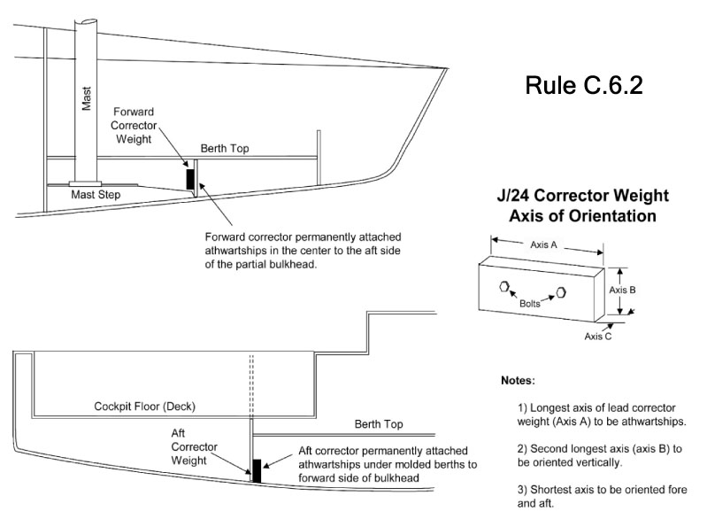

H.1.2 PLAN A – DECK LAYOUT
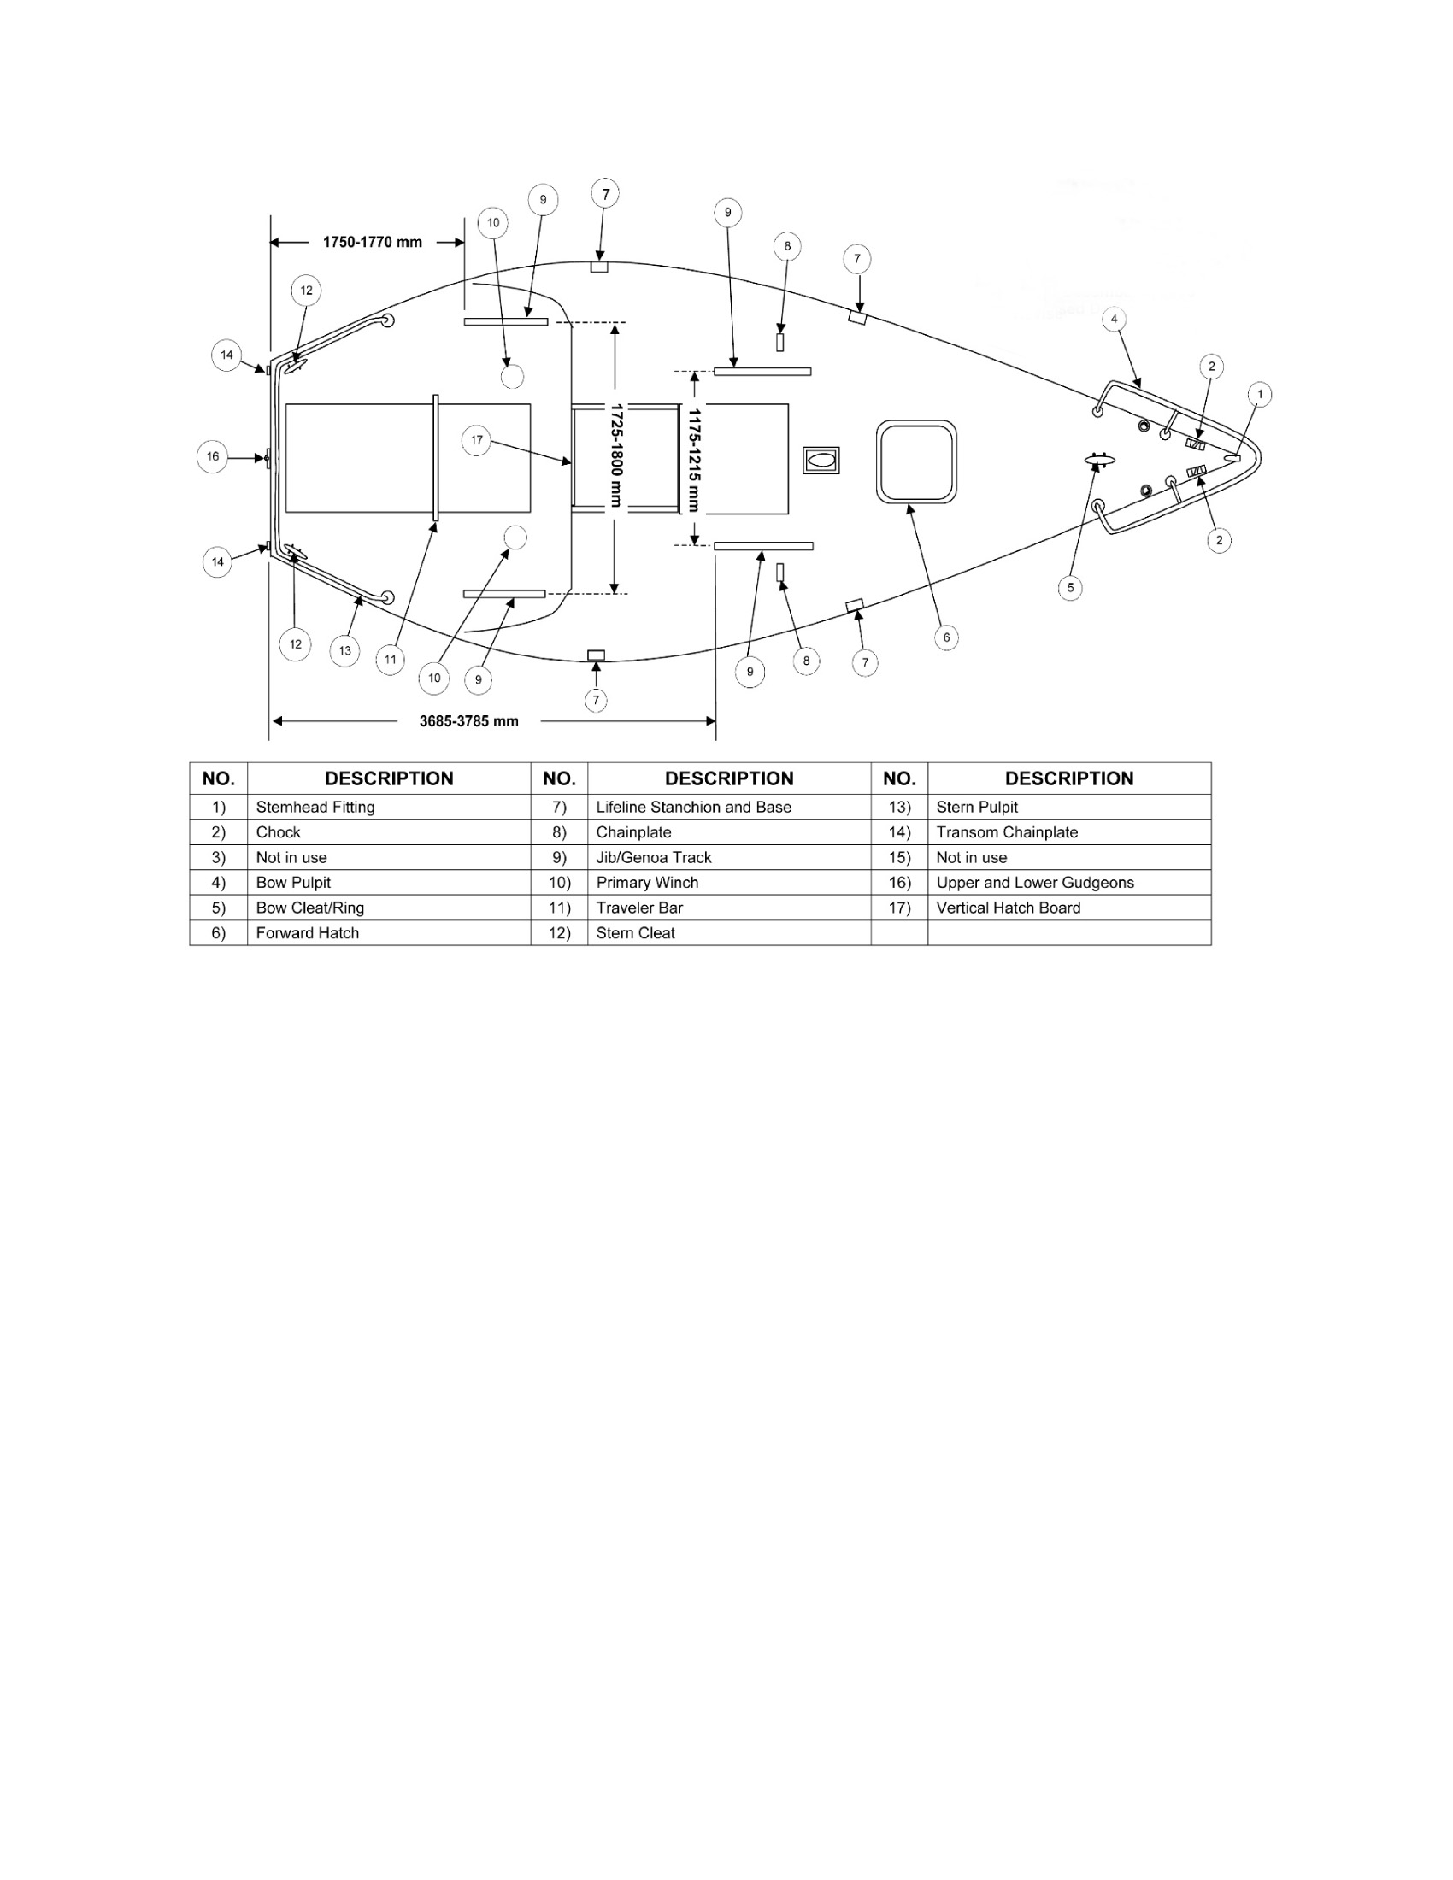

H.1.3 PLAN A – INTERIOR LAYOUT I
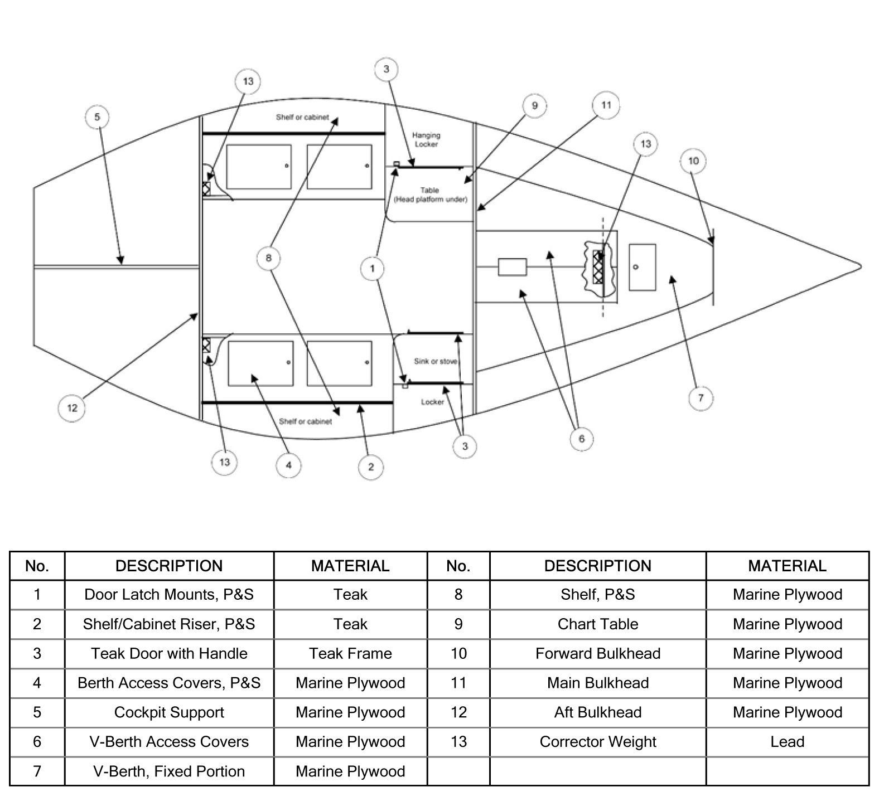

H.1.4 PLAN A – INTERIOR LAYOUT II
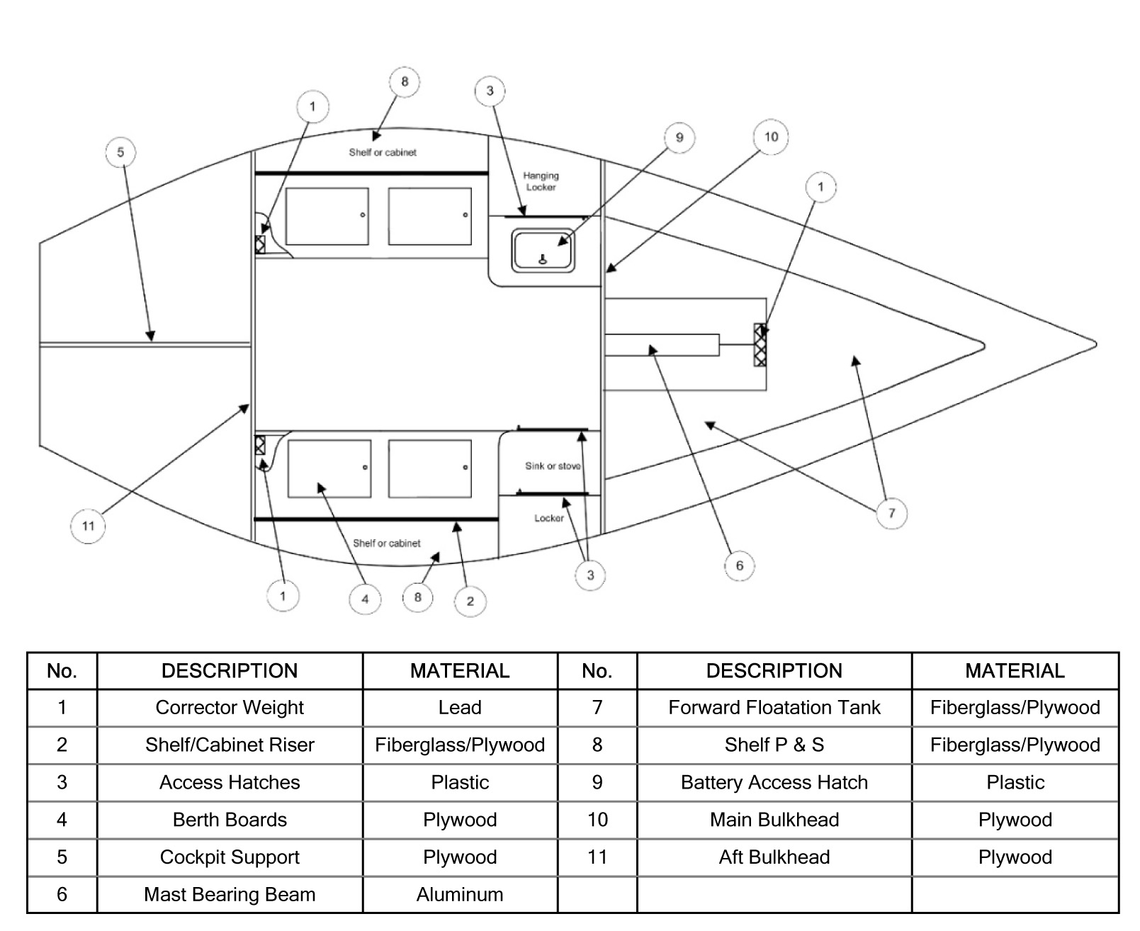

H.1.5 PLAN A – INTERIOR LAYOUT III
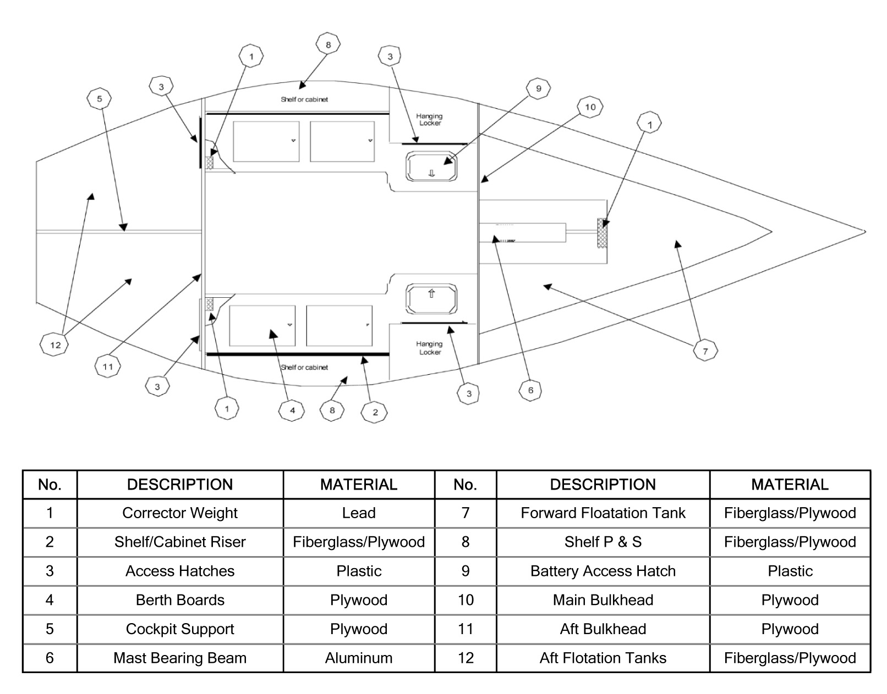
H.2 Plan B – Measurement Points and LoGo
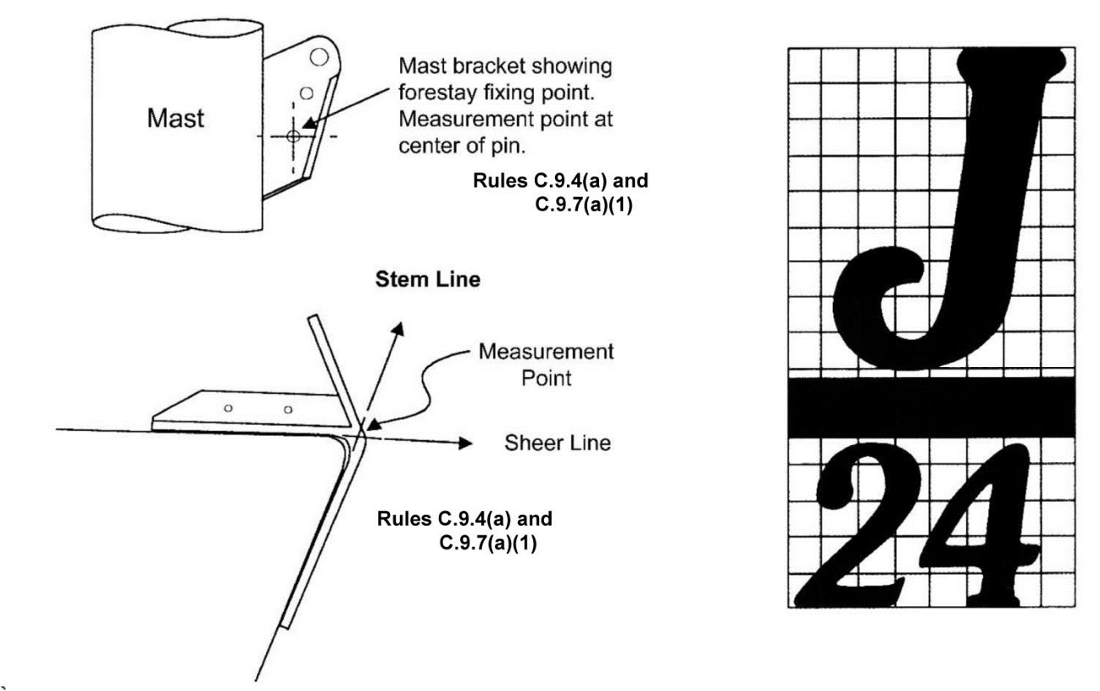

H.3 PLAN C – KEEL
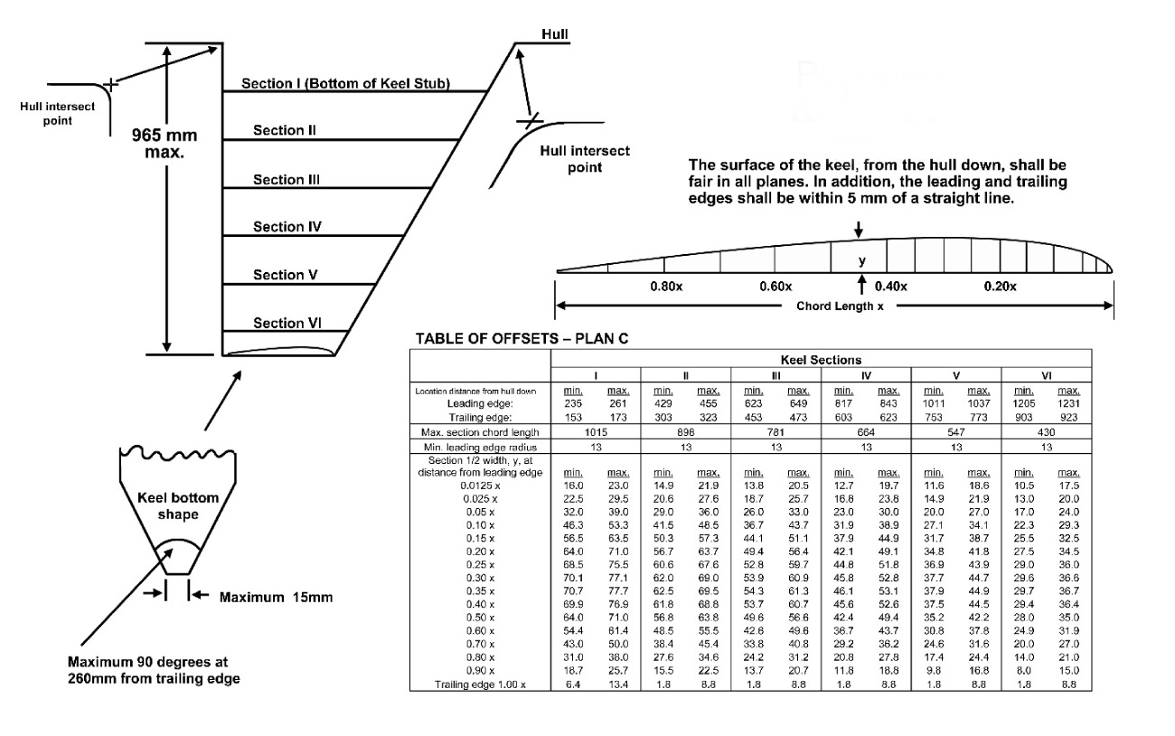

H.4 PLAN D – RUDDER
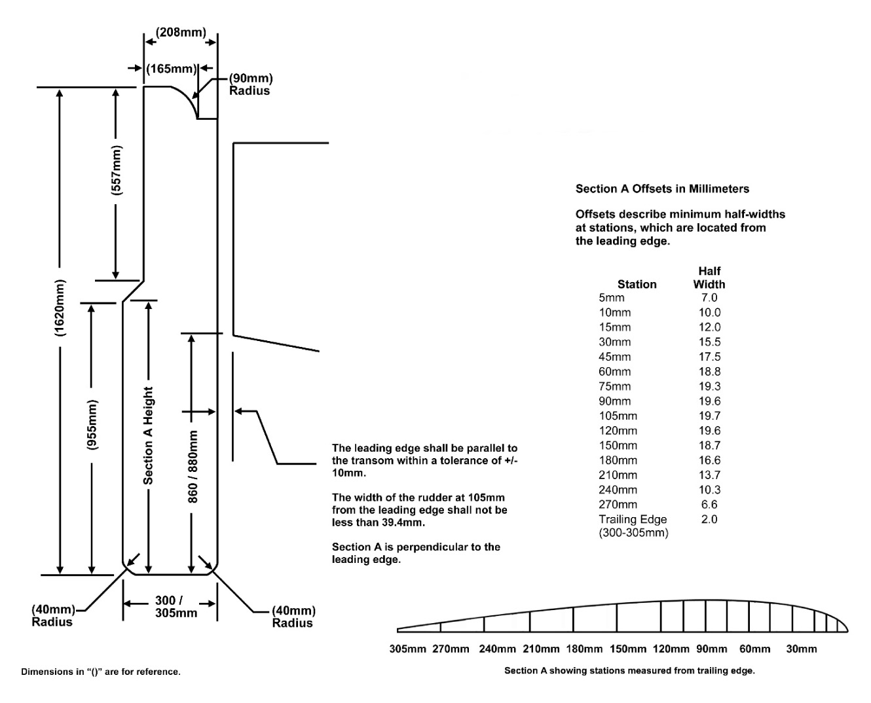

H.5 SAILS
H.5.1 – MAINSAIL
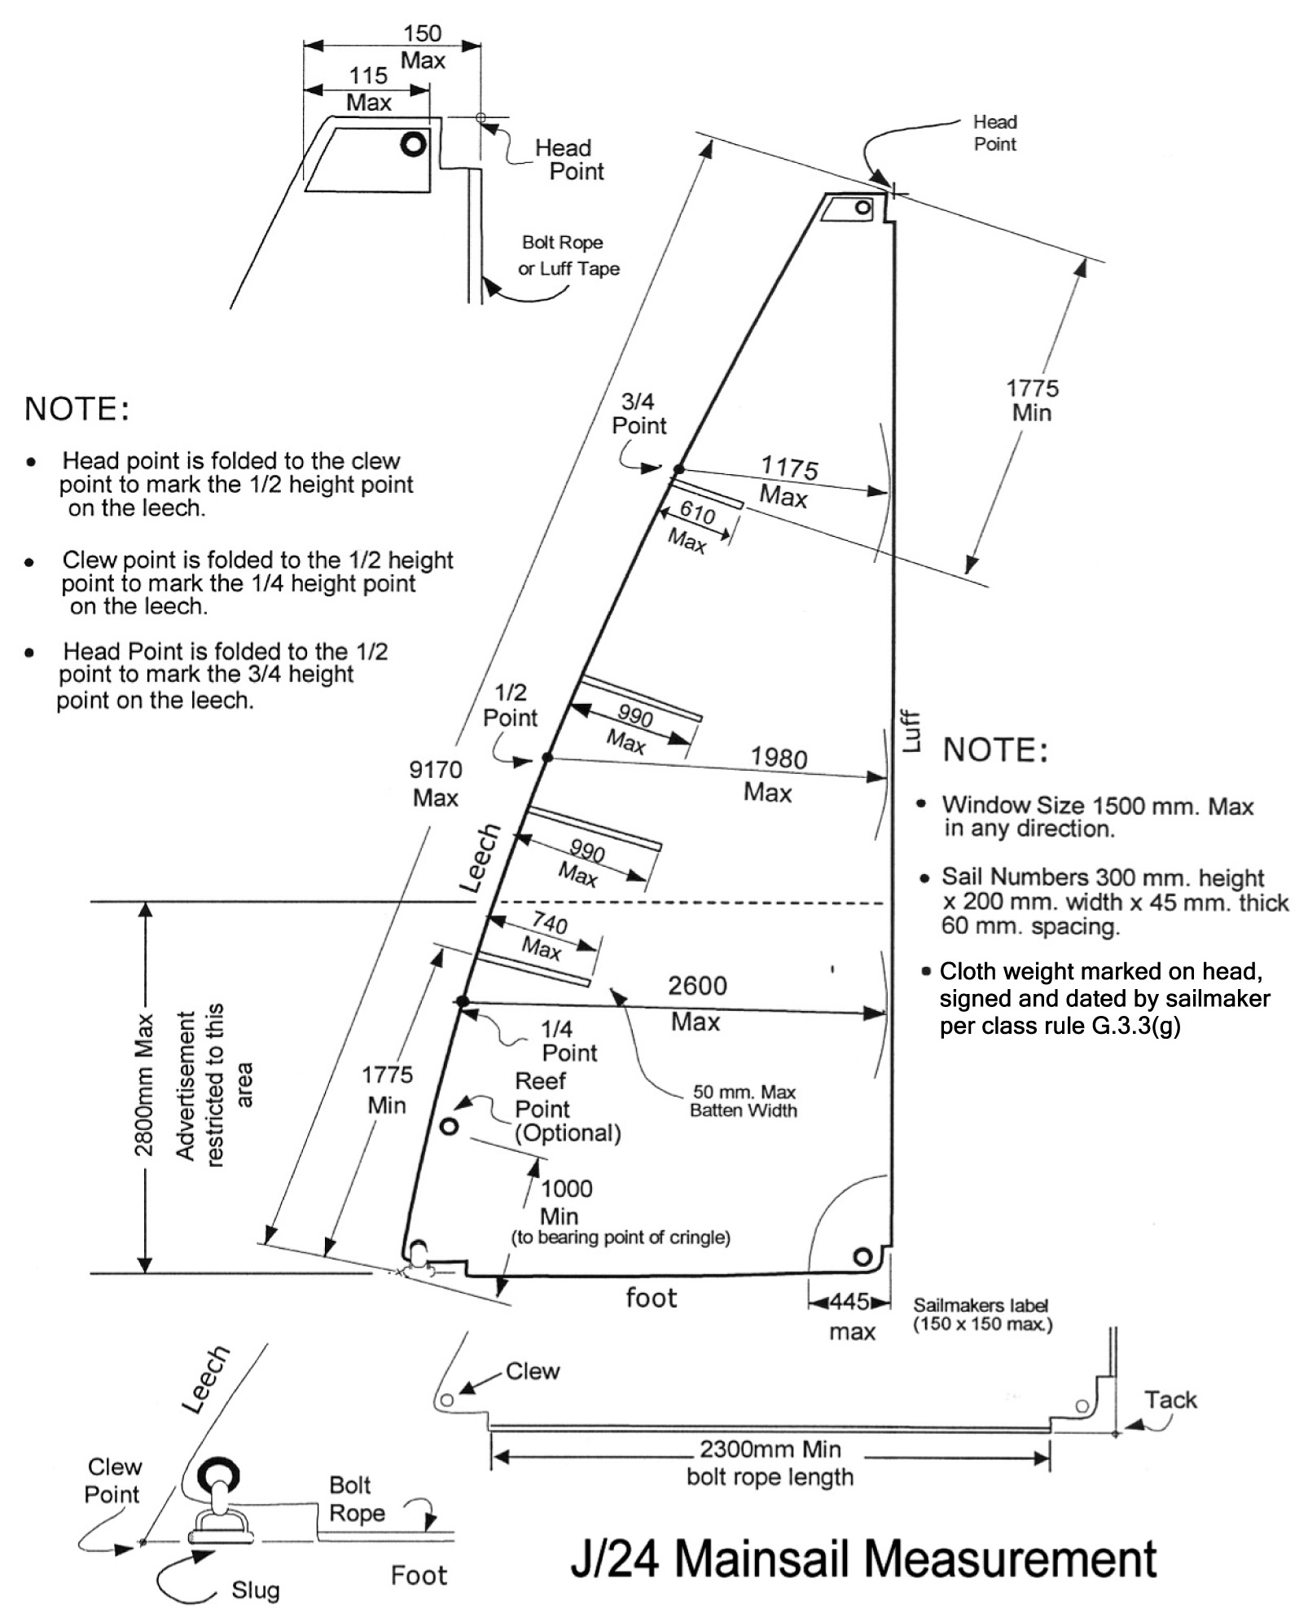

H.5.2 – GENOA
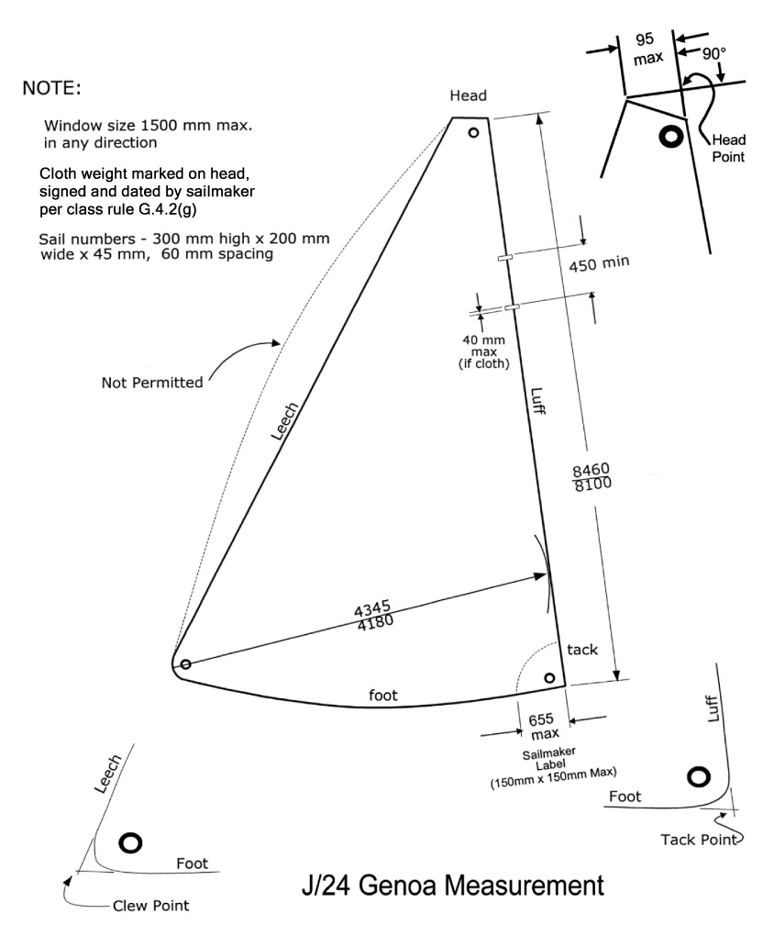

H.5.3 – JIB
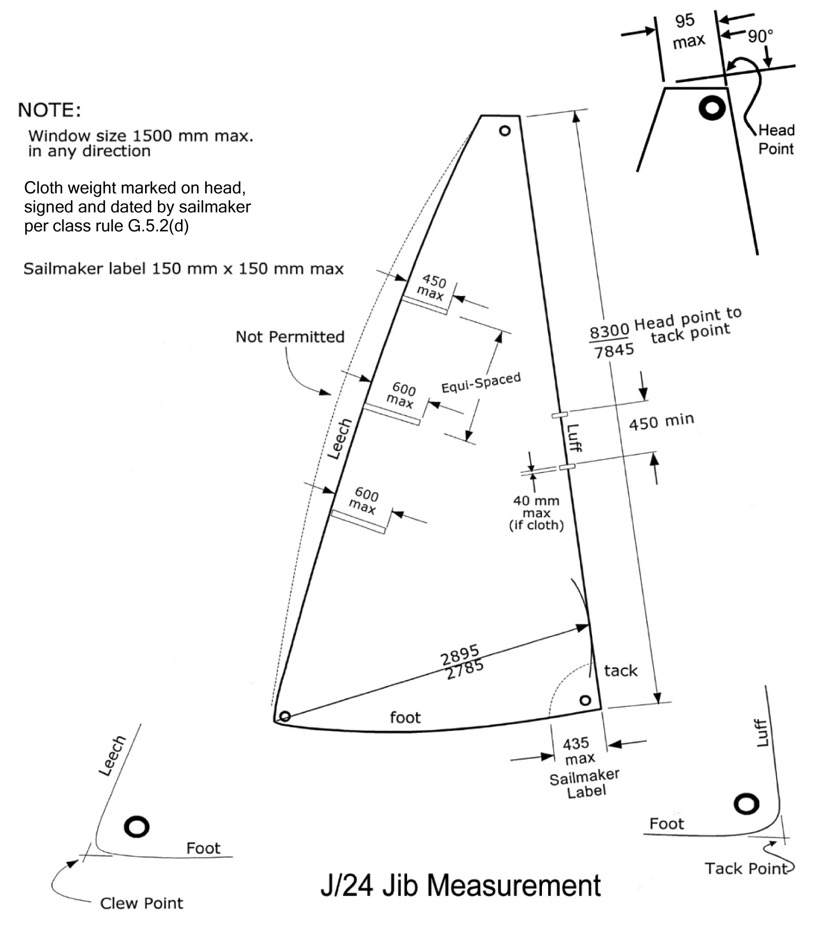

H.5.4-SPINNAKER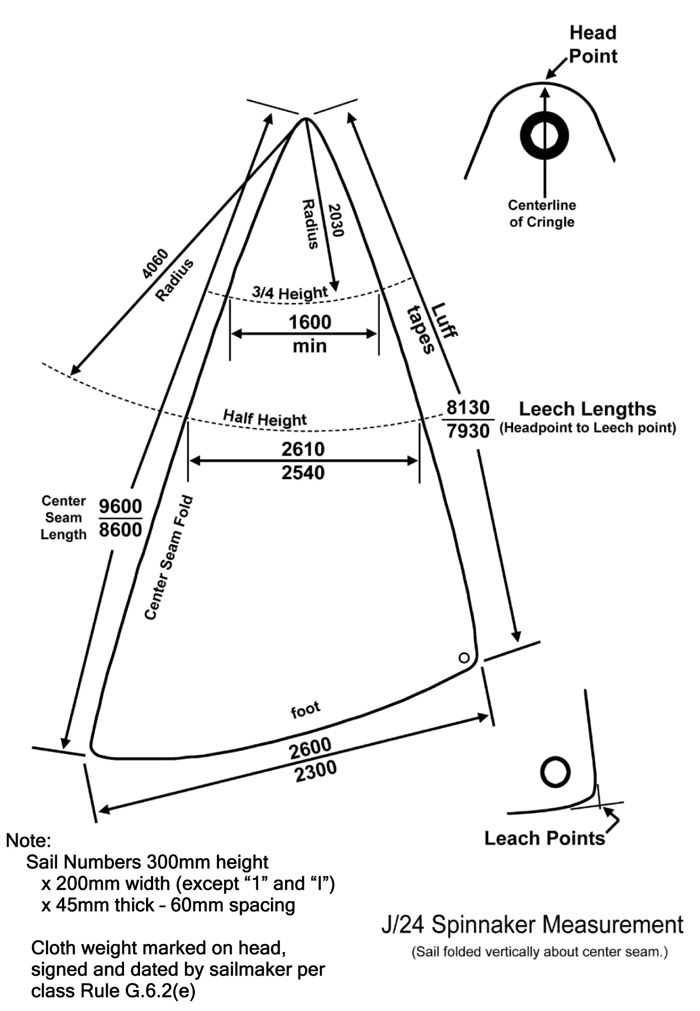

Section J – Event Class Rule Change Options
These rules must be invoked individually by the sailing instructions. The default is these rules do not apply.

J.1 SPARE SPINNAKER
One spare class Spinnaker (that meets the requirements of class rule G.6) may be presented for measurement and registration for an event, and carried aboard, but shall not be used during an event except when the primary spinnaker has been lost or damaged to the point where it cannot be effectively repaired while afloat. This changes class rule C.10.2 and G.2(a).

J.2 LEGS-IN CREW POSITIONING
(Option for team-racing, match-racing, frostbiting, and provided-boat events).
Class rule C.2.2(b) is replaced with the following: “While seated on the deck, crew shall have their legs inboard of the sheerline.”

J.3 CREW LIMITATIONS This changes Class rule C.2.1
J.3.1 Total crew weight (in swim wear or underwear) shall not exceed 340kg.
J.3.2 A crew nominated or listed for this event shall remain the same throughout the event. Emergency
changes may be made only with written permission of the jury.
J.3.3 A crew nominated or listed for this event may be different for different days only if scheduled in
advance at registration. Emergency changes may be made only with written permission of the jury.

J.4 JIB ONLY
The event will be sailed with three sails. A jib as described in class rule G.5 shall be the only headsail permitted while racing.

Effective Date:
Published Date:
Previous issues:
© ISAF 200X

