Notice of Race
2016 J/24 World Championship
16-23 September 2016
Wakayam Sailing Club and the International J/24 Class Association
Wakayama/Japan
www.j24.gr.jp/2016_worlds/
1. Rules
1.1 The regatta will be governed by the rules as defined in the Racing Rules of Sailing (RRS) 2013 – 2016.
1.2 The following prescriptions of Japan Sailing Federation to RRS 67 and 91 shall apply:
Rule 67: Liability for damages arising from a breach of a “rule” defined in the Racing Rules of Sailing shall not be connected with a penalty taken by a boat involved in the incident, or a decision made by the protest committee or the appeals committee.
Rule 91: When an organizing authority of an international event held in Japan intends to appoint an international jury under rule 91(b), it shall obtain approval from the JSAF before the event under rule N.1.1, except ISAF events or when the international jury is appointed by the ISAF under rule 89.2(b).
1.3 The Regatta Regulations of the International J/24 Class Association (IJCA) will apply.
1.4 RRS 41 will be changed as follows: From the time a boat leaves her mooring for the first race of each day until she returns to her mooring and while not racing, she shall not receive outside help except as permitted by RRS 41 from any outside source except other competitors and official boats under the direction of the organizing authority. While racing, RRS 41 applies without modification. If RC displays Race Signal AP over H, these additions to RRS 41 are suspended until a boat leaves her mooring again. This will change the preamble to Part 4 of the RRS.
1.5 Bow numbers will be assigned to each boat and will be used as identification for the boat during the regatta. Bow numbers shall be applied in accordance with the instructions supplied and shall remain affixed until after a boat hauls out at the end of the regatta.
1.6 In accordance with RRS G3, a boat chartered or loaned for this event may carry national letters or a sail number in contravention of the class rules.
1.7 If there is a conflict between languages, the English text will take precedence.
1.8 Part 5, Section B of the RRS and RRS 41 will be changed to permit Protest Arbitration.
1.9 RRS 61.1(a) will be changed so that the red flag displayed by a protesting boat shall have a hoist of not less than 150mm and a fly of not less than 200mm.
1.10 RRS 44.3 will be changed so that code flag “I” may be used as the yellow flag and so that the flag used (either yellow or code flag ”I”) shall have a hoist of not less than 150mm and a fly of not less than 200mm.
1.11 Class rule 5.3 will be changed in the Sailing Instructions so that the crew that is nominated or listed for the regatta shall remain the same throughout the event except for emergency or extraordinary circumstances and only changed with written permission of the Race Committee.
2. Advertising:
2.1 Competitor advertising shall comply with RRS 80 and ISAF Regulation 20.
2.2 Boats may be required to display advertising chosen and supplied by the organizing authority.
3. Eligibility and Entry:
3.1 The World Championship is open to J/24 Class boats as defined by the IJCA class rules, and that qualify as prescribed in the IJCA Regatta Regulations, and whose entries are accepted by the organizing authority.
3.2 Championship helmspersons must be either nationals or residents and members of the National J/24 Class Association of the country that they represent, and they must have qualified as defined by their National J/24 Class Association to represent their country.
3.3 Eligible boats may enter by completing the required form on the event web site and paying
the entry fee by 01 AUG 2016.
3.4 Late entries will be accepted with an additional late fee of JPY10000.
3.5 If there are co-skippers, one of them shall be designated as the primary skipper for this regatta.
4. Fees:
4.1 The required entry fee is JPY70000.
4.2 Fee includes measurement, launching, hauling, storage/mooring while at the regatta, racing, tickets to the principal events for all crew, and prizes.
4.3 Additional individual social function passes may be purchased at registration for an additional fee by JPY cash.
4.4 Entry fees are payable as directed on the event web site by 01 AUG 2016.
5. Schedule:
5.1 Shedule
Day | Date | Time | Event/Activity
Friday | 16 September | 0800 - 1800 | Registration/Measurement/Crew Weigh-in
Saturday | 17September | 0800 - 1800 | Registration/Measurement/Crew Weigh-in
Sunday | 18 September | 0900 – 1700  0900 – 1200  1200  1400  1800  1800  1800 | Registration/ Crew Weigh-in  Measurement  Skippers’ Briefing  Practice Race  Competitors’ Meeting  Opening Ceremonies  All Boats Afloat
Monday | 19 September | 0800 – 0830  1030  1800 | Crew Weigh-in*  Warning for First Race of the Day  Social Event
Tuesday | 20 September | 0800 – 0830  1030  1800 | Crew Weigh-in*  Warning for First Race of the Day  Social Event
Wednesday | 21 September | 0800 – 0830  1030  1800 | Crew Weigh-in*  Warning for First Race of the Day  Social Event
Thursday | 22 September | 0800 – 0830  1030  1800 | Crew Weigh-in*  Warning for First Race of the Day  Social Event
Friday | 23 September | 0800 – 0830  1030  1500  1800 | Crew Weigh-in*  Warning for First Race of the Day  No Warning after this time  Closing Ceremonies and Awards
* These scheduled crew weigh-ins are only for RC approved replacement crews per 1.11.
5.2 Ten races are scheduled over five consecutive days.
5.3 Two races are scheduled per day except that no more than one race may be scheduled on the first day unless a successful practice race has been held. One extra race per day may be sailed provided that the regatta does not become more than one race ahead of schedule and the change is made according to the provisions of the Sailing Instructions. If the regatta is behind schedule, extra races to a maximum of four races may be sailed in a single day.
6. Registration and Measurement:
6.1 At registration each boat shall present:
(a) A valid, IJCA issued Measurement Certificate, Including Part C: Inventory of Required and Optional Equipment.
(b) Proof of current marine liability insurance coverage in the amount of JYE 50000000.
(c) Proof of J/24 Class Association membership in the country they represent for the owner and the helmsperson.
6.2 All competitors will be weighed during registration. Competitors must have a passport or other photo identification at weigh-in.
6.3 Inspection and measurement will be carried out on all boats and sails in accordance with the class rules.
6.4 Boats will be subject to inspection at any time during the regatta.
7. Sailing Instructions:
7.1 The Sailing Instructions will be available before 15 AUG 2016 at www.j24.gr.jp/2016_worlds/www.
8. Venue:
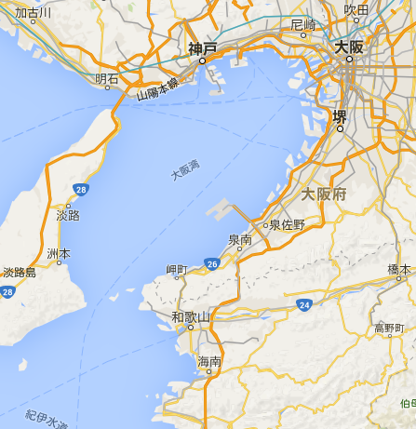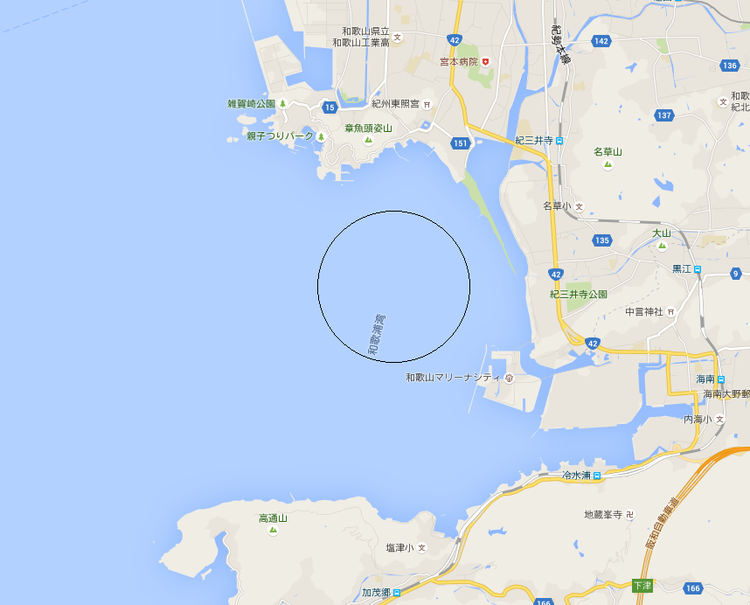
Ｋａｎｓａｉ ＩＮＴ ＡＰ
Ｏｓａｋａ
ＷＳＣ
ＷＳＣ
9. The Courses:
9.1 The courses to be sailed will be windward/leeward with 4 or 5 legs.
92 The target time for each race is approximately 75 – 90 minutes.
9.3 An offset mark at the weather mark will be used. Exceptions will be described in the Sailing Instructions
9.4 A gate at the leeward mark will be used. Exceptions will be described in the Sailing Instructions.
10. Penalty System:
10.1 The Scoring Penalty, RRS 44.3, will apply, with penalties as modified by the IJCA. See J/24 Scoring Penalties on the Class website, http://www.j24class.org Class Documents. These modifications will be printed in the Sailing Instructions.
10.2 An International Jury will be appointed according to RRS 70.5, whose decisions will be final.
10.3 Arbitration may be used prior to the protest hearing for incidents involving the rules of Part 2 or RRS 31.
10.4 Some other penalties as per RRS 64.1 will apply for breaking some IJCA rules. See J/24 Class Rule Penalties on the Class website. These penalties will be printed in the Sailing Instructions.
11. Scoring:
11.1 Four races are required to be completed to constitute a championship.
11.2 When fewer than five races have been completed, a boat’s series score will be the total of her race scores. When five or more races have been completed, a boat’s series score will be the total of her race scores, excluding her worst score. Appendix A will be changed accordingly.
11.3 Boats failing to finish within 20 minutes after the first boat sails the course and finishes will be scored Time Limit Expired (TLE) without a hearing. Boats scored TLE will be scored points equal to the number of boats finishing within the time limit plus two points by the race committee. RRS A4.2, A5 and A11 will be changed accordingly.
12. Support Boats:
12.1 Support boats shall comply with NOR 1.4.
12.2 Support boats shall register during scheduled registration, declaring to which boat or boats they are attached. They may be required to display an identification flag supplied by the organizing authority.
13. Berthing:
13.1 Boats shall be kept in their assigned places or areas, as directed by the organizing authority.
14. Haul-out Restrictions:
14.1 Boats shall be afloat by 1800 on 18 SEP and shall not be hauled out during the regatta except with, and according to the terms of prior written permission of the jury. This includes rudders.
15. Diving Equipment, Plastic Pools and Other Prohibited Actions:
15.1 Underwater breathing apparatus and plastic pools or their equivalent shall not be used between the time the boat is afloat and the end of the regatta. The hull may be cleaned at any time by swimming or keelhauling using ropes, cloth or other equipment designed for that use.
15.2 Careening by any means for the purpose of cleaning or inspecting the hull is prohibited during the regatta.
16. Radio Communications:
16.1 Except in an emergency, a boat shall neither make radio transmissions while racing nor receive radio communications not available to all boats. This restriction also applies to mobile telephones.
16.2 The race committee may choose to make VHF radio communications to the fleet on a channel to be announced in the sailing instructions. It is strongly encouraged that each boat have a VHF radio on board capable of receiving these communications.
17. Prizes:
17.1 Prizes will be awarded to top 7 boats entered.
17.2 A prize will be awarded to the top youth entry comprised of a crew in which none are over the age of 25 years.
17.3 A prize will be awarded for the top women’s entry in which the entire crew is comprised of women.
18. Disclaimer of Liability:
18.1 Competitors participate in the regatta entirely at their own risk. See RRS 4, Decision to Race. The organizing authority will not accept any liability for material damage or personal injury or death sustained in conjunction with or prior to, during or after the regatta.
18.2 All competitors will be required to sign a Competitor Liability Waiver form to be provided in the registration package.

19. Insurance:
19.1 Each participating boat shall be insured with valid third party insurance with a minimum coverage of JPY 50000000 per incident or the equivalent.
20. Media Rights:
20.1 Competitors give absolute right and permission to the IJCA, the JAPANJ/24 Class Association, Wakayama Sailing Club and the event sponsors to use, publish, broadcast or otherwise distribute for promotional, advertising or any other purpose, any images and sound recorded during the event of persons and boats free of any charge.
21. Further Information, contact the following:
www.j24.gr.jp/2016_worlds/

